

**CSE302: Database Systems**

**[Fall 2020]**

**Project Report**

**Course Resource Management System**

URL: https://apex.oracle.com/pls/apex/2018-2-60-028/r/course-resource-management12849/

**Course Code and Section:** **CSE302**

**Section: 01**

**Submitted by:**

|  |  |  |
| --- | --- | --- |
| **Student ID** | **Student Name** | **Contribution Percentage** |
| 2018-2-60-102 | Fahadul Islam | **40** |
| 2018-2-60-028 | Rakibul Huda | **30** |
| 2018-2-60-60 | Md.Asif Shariar | **30** |

# **Final version of the E-R Model of the Project**

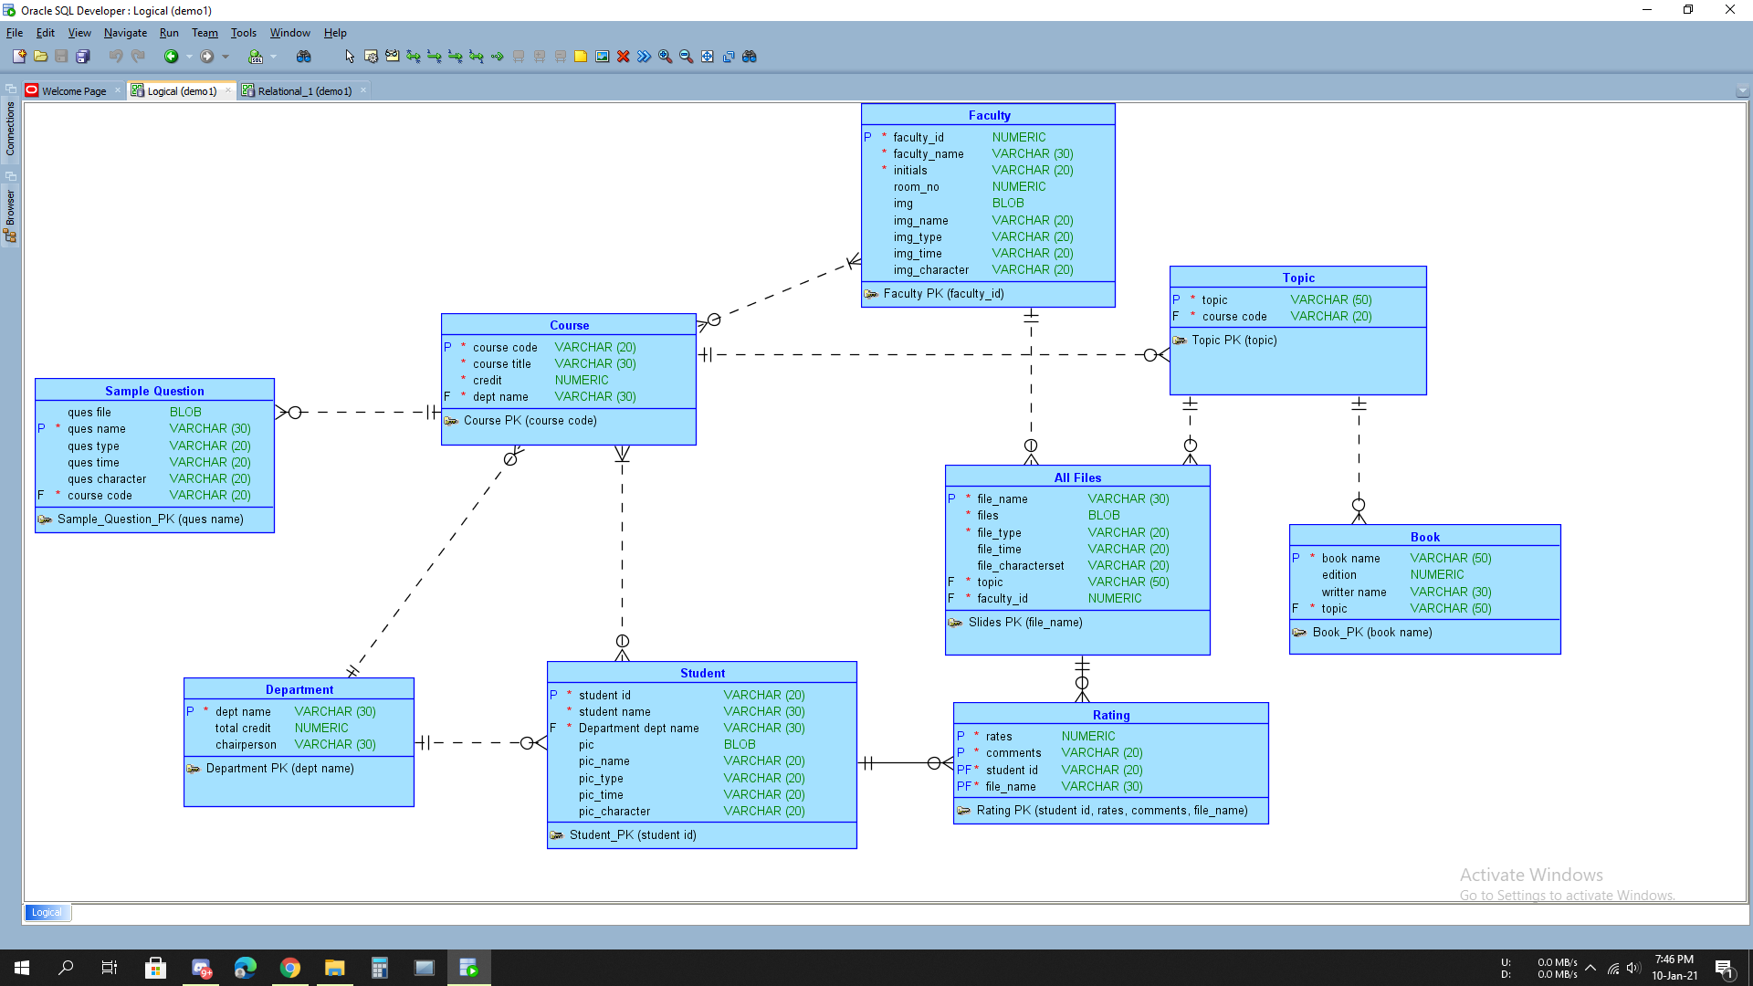

# **Final Version of the Relational Data Model of the Project**

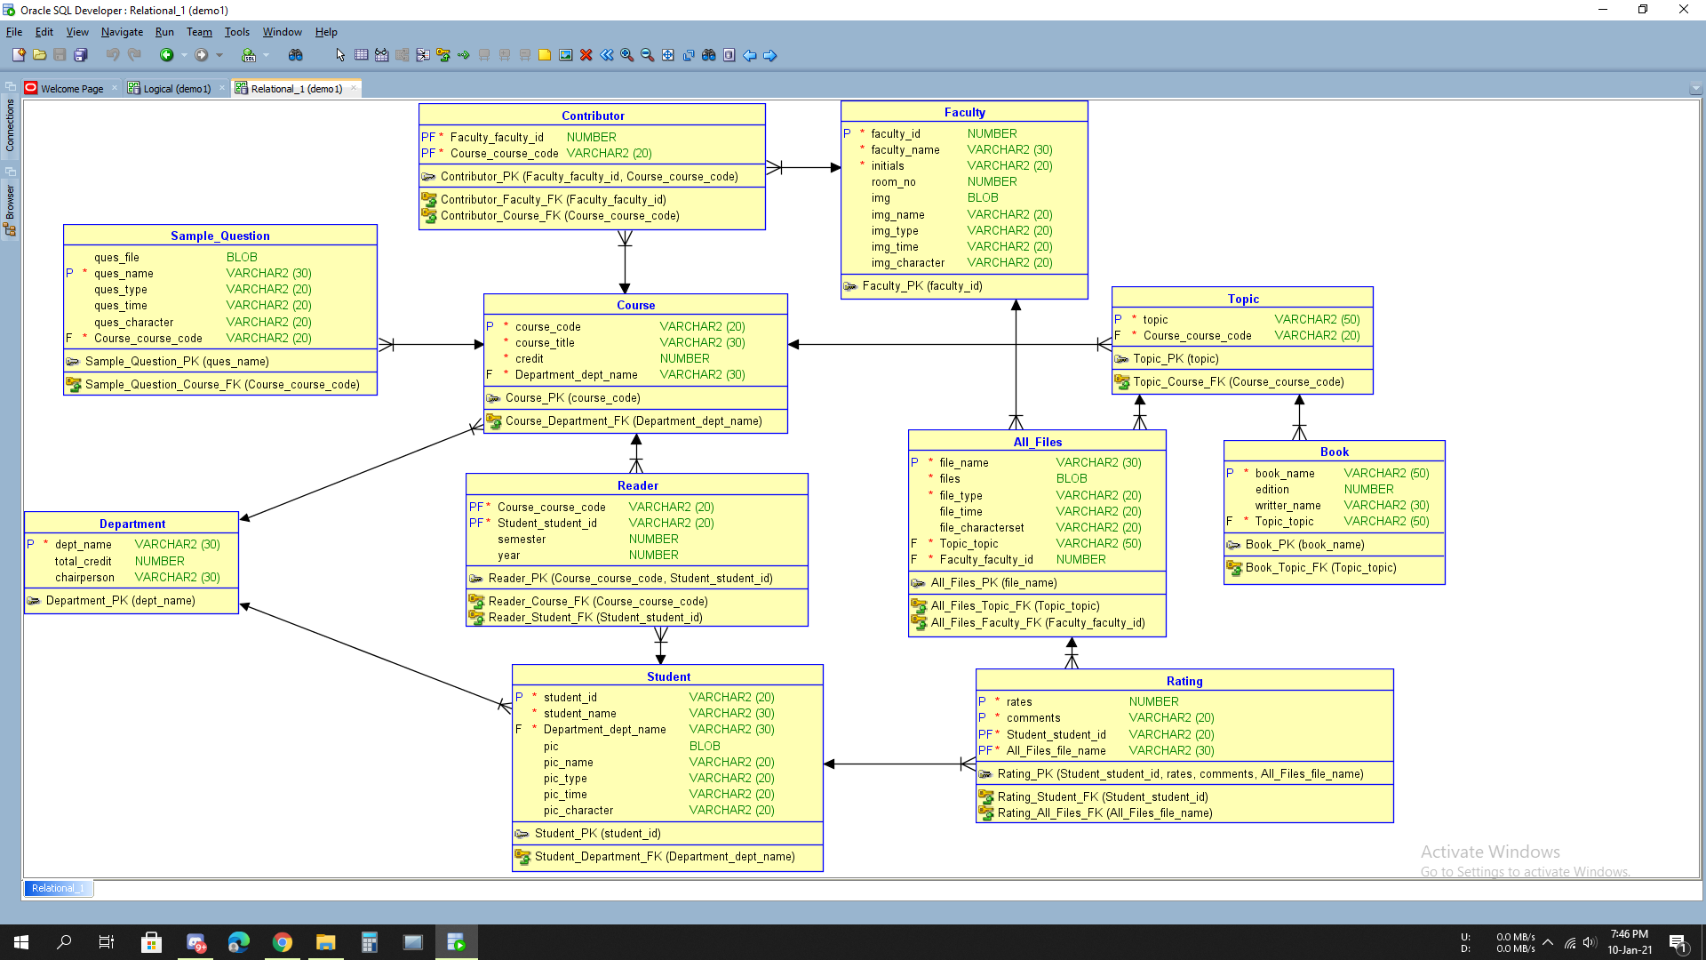

# Implementation Checklist

|  |  |
| --- | --- |
| Description | Remarks |
| Project ID | 2849 |
| Workspace Name | 2018-2-60-028 |
| Workspace Email | gmhuda9035@gmail.com |
| Workspace Password | 12345rakib98 |
| Authentication Type | Custom |
| Username and Password to Login |  |
| Username:  *admin*  *faculty*  *student* | Password:  *admin*  *faculty*  *student* |
| Uploaded and Displayed Images in Reports | Yes |
| Implemented Page-wise Authorization | Yes |
| Number of Reports with Forms | 11 |
| Number of Master-detail Forms | 8 |
| Number of Reports based on Queries, Aggregate Queries | No |
| Number of Parameterized Reports | 12 |
| Number of Graphs/Charts | 5 |
| Included any trigger/other feature which is not taught in class. If yes, please explain briefly. | Trigger has been used in **User** and **About Admin** report. At **User** and **About Admin** form**,** Admin can add data and the **Number** type primary key will be automatically added |
| Write the most unique feature/functionality in your application or the page of your application which you are proud of. Explain briefly. | Parameterized Reports 2.0 which has two selective-list to get the specific data. User will select options from two different selective-list and rows will be shown according to selection |

# 4. Reports with Forms

|  |  |  |
| --- | --- | --- |
| Report Page Number and Name | Form Page Number and Name | Table |
| 12. **Course** | 27. Course | Course |
| 6. **Faculty** | 7. Faculty | Faculty |
| 2. **Student** | 3. Student | Student |
| 22. **Subscribe** | 24. Subscribe | Reader |
| 4. **Department Report** | 5. Department Form | Department |
| 10**. All Files Report** | 11. All Files Form | All_Files |
| 14. **Topic Report** | 15. Topic Form | Topic |
| 16. **Book Report** | 17. Book Form | Book |
| 18. **Rating Report** | 19. Rating Form | Rating |
| 20. **Contributor Report** | 21. Contributor Form | Contributor |
| 8. **Sample Question** | 78.Sample Question | Sample Question |
| 97. **User** | 98. User | Users |
| 99. **About Admin** | 100. About Admin | Admins |

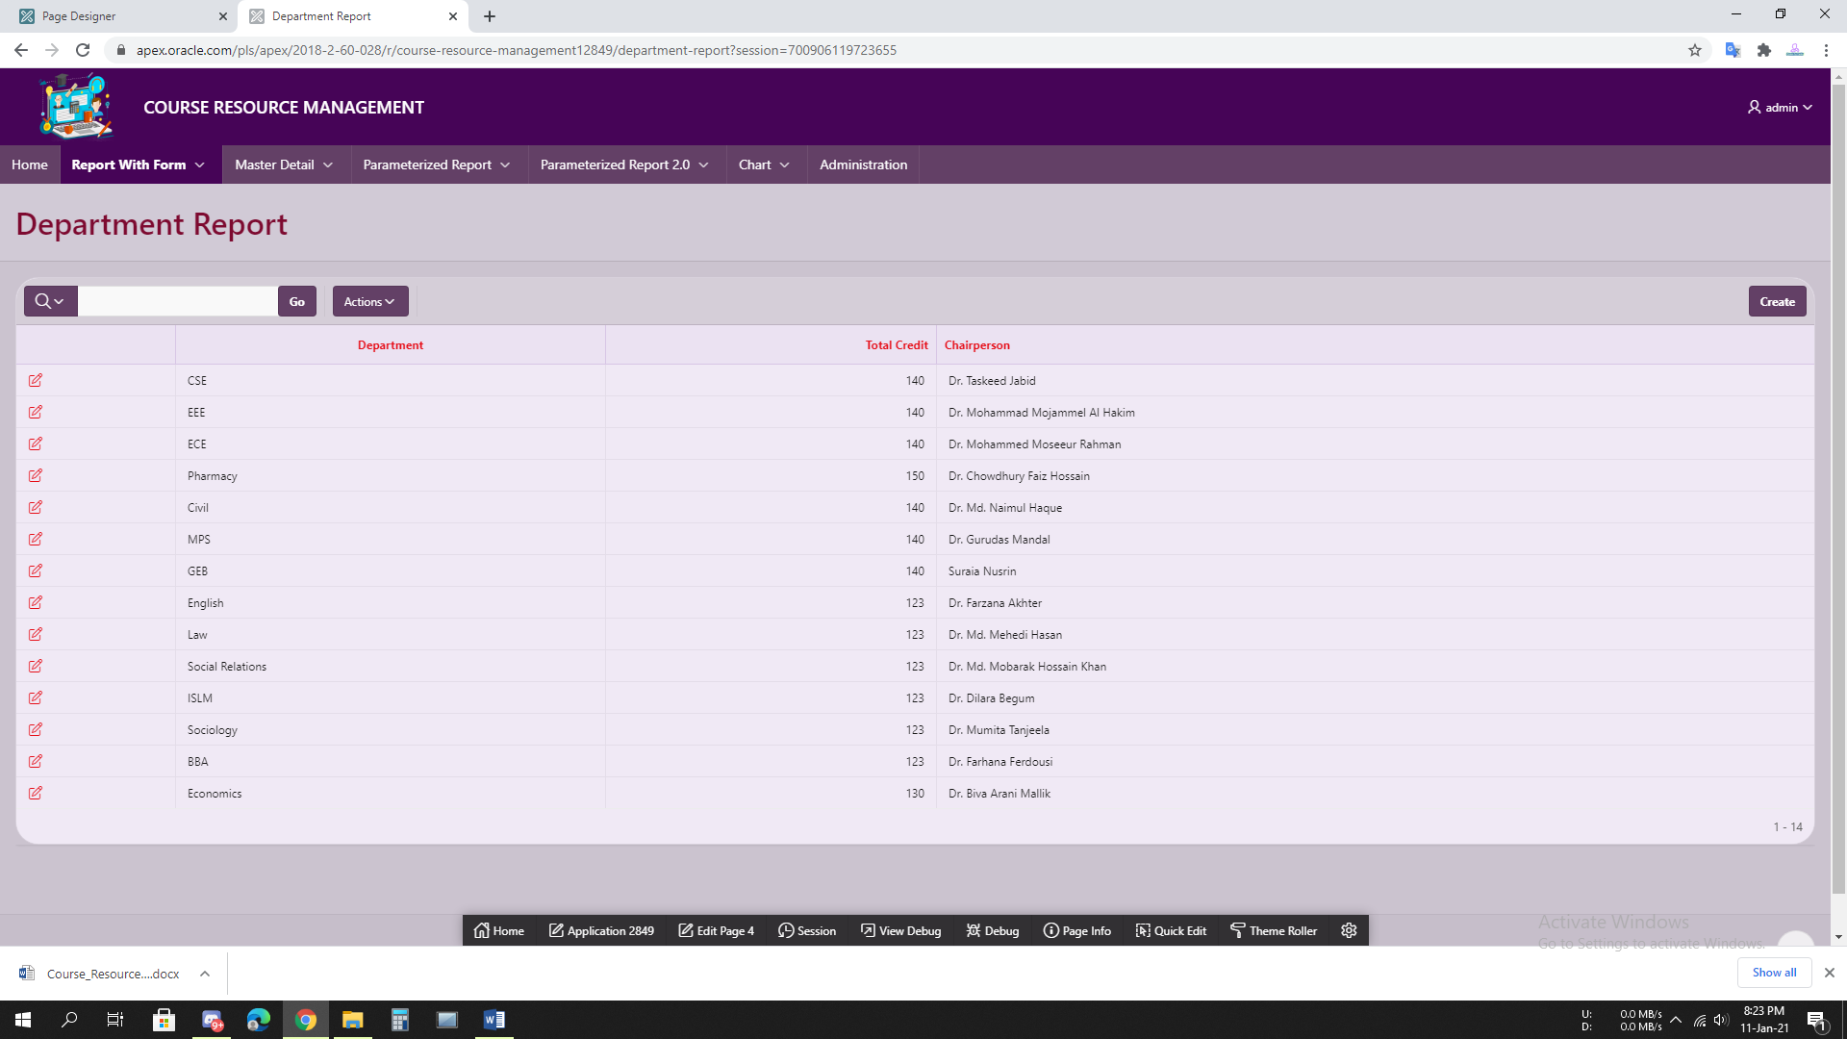

**4.1 Figure: Department Report**

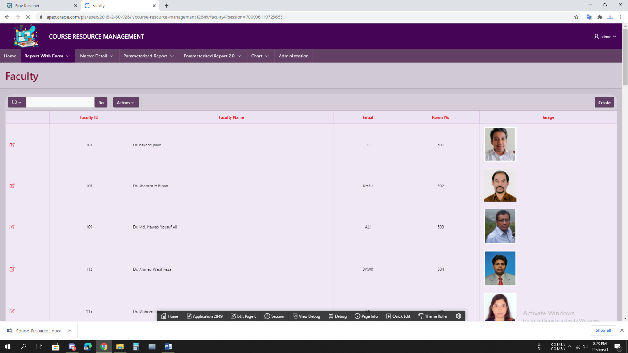

**4.2 Figure: Faculty**

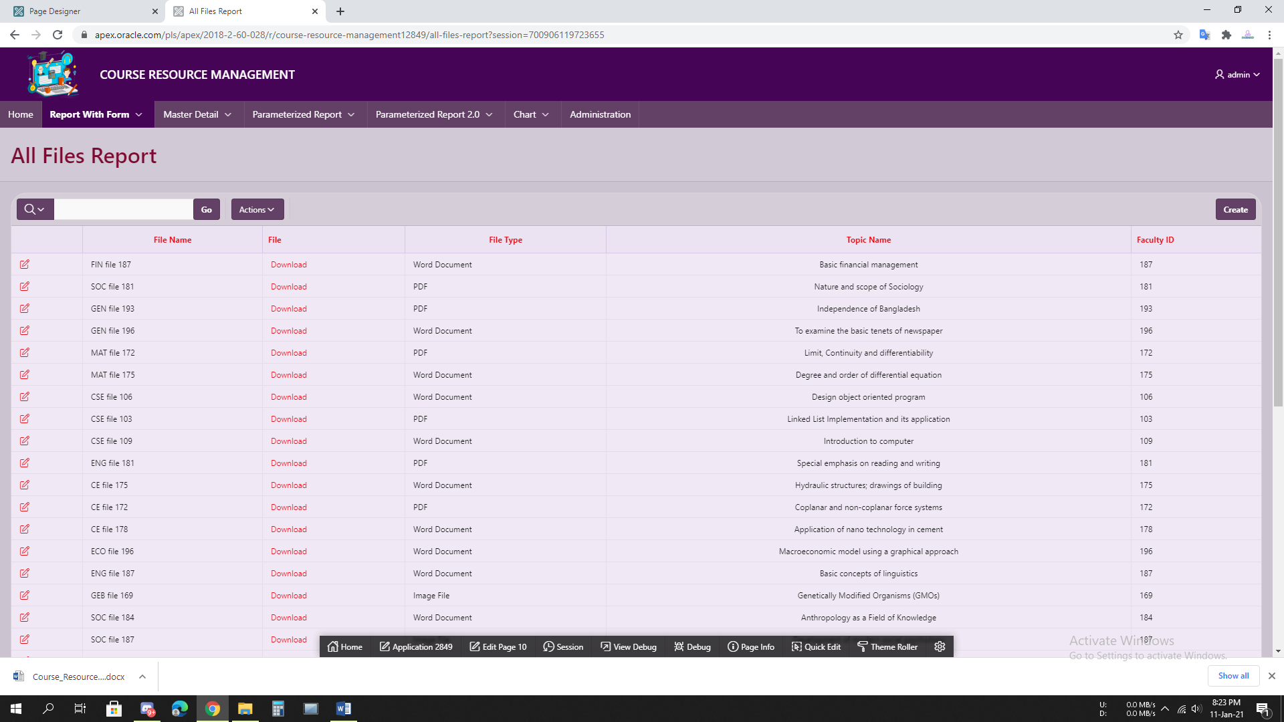

**4.3 Figure: All Files Report**

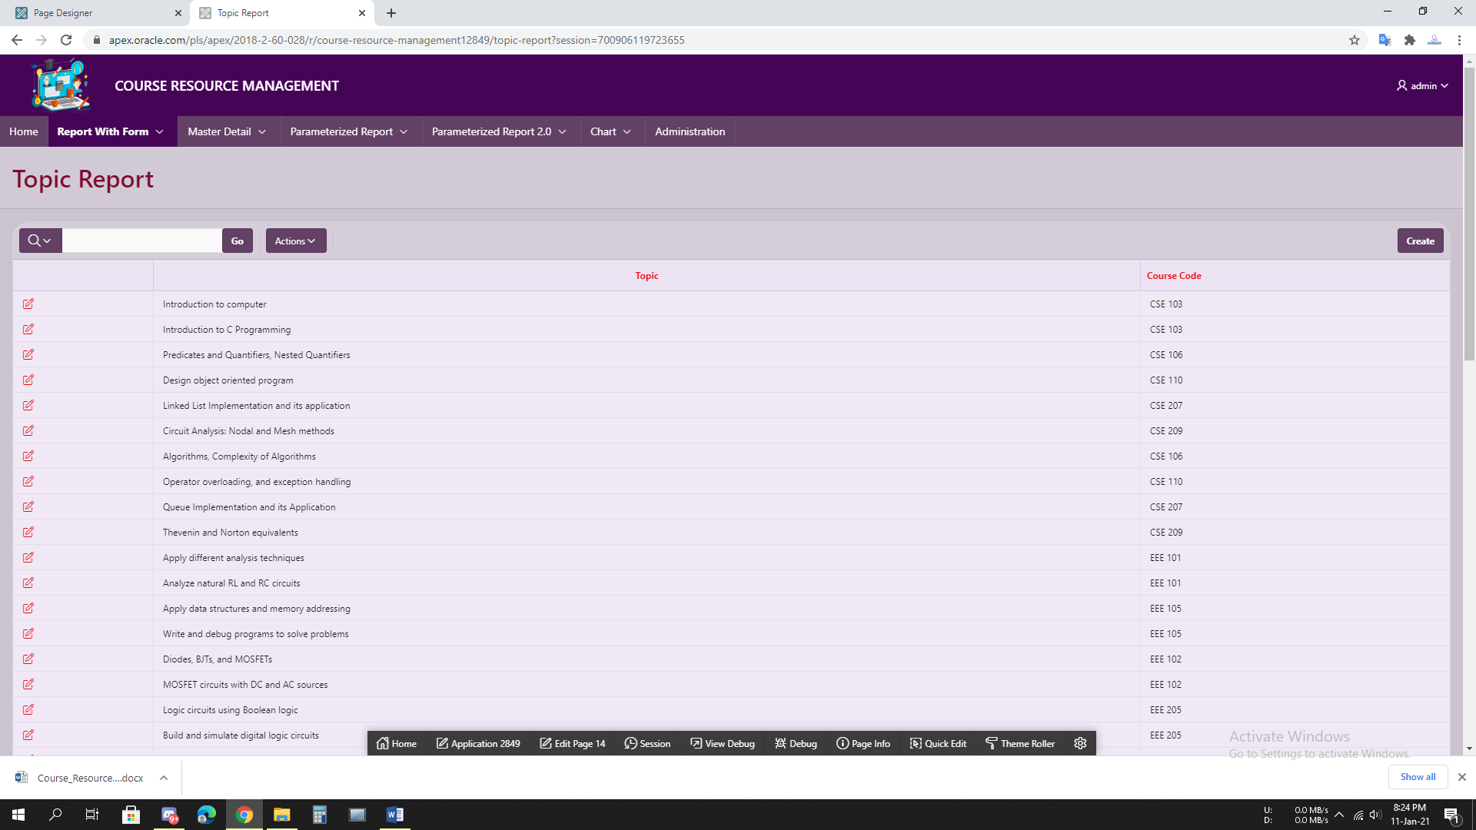

**4.4 Figure: Topic Report**

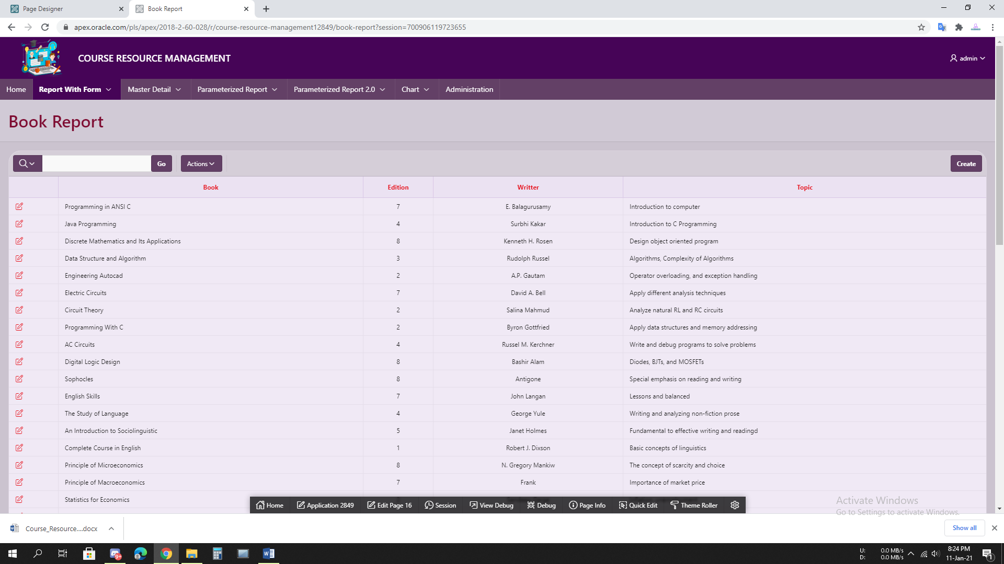

**4.5 Figure: Book Report**

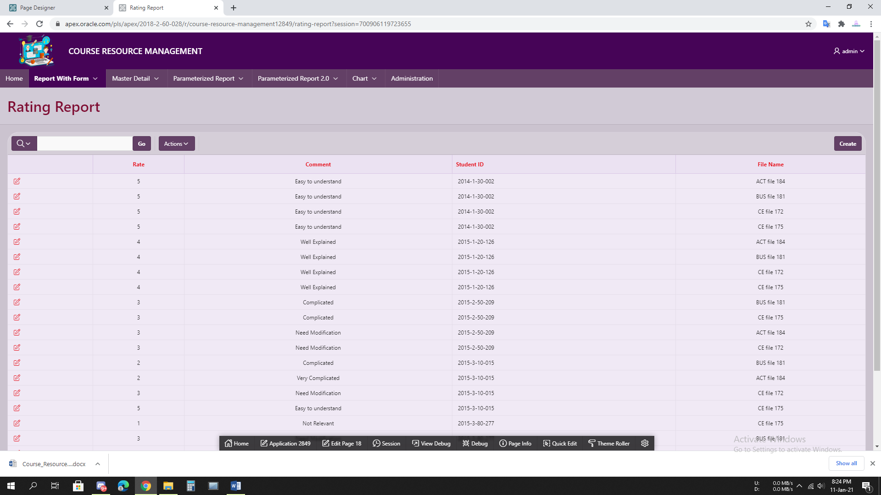

**4.6 Figure: Rating Report**

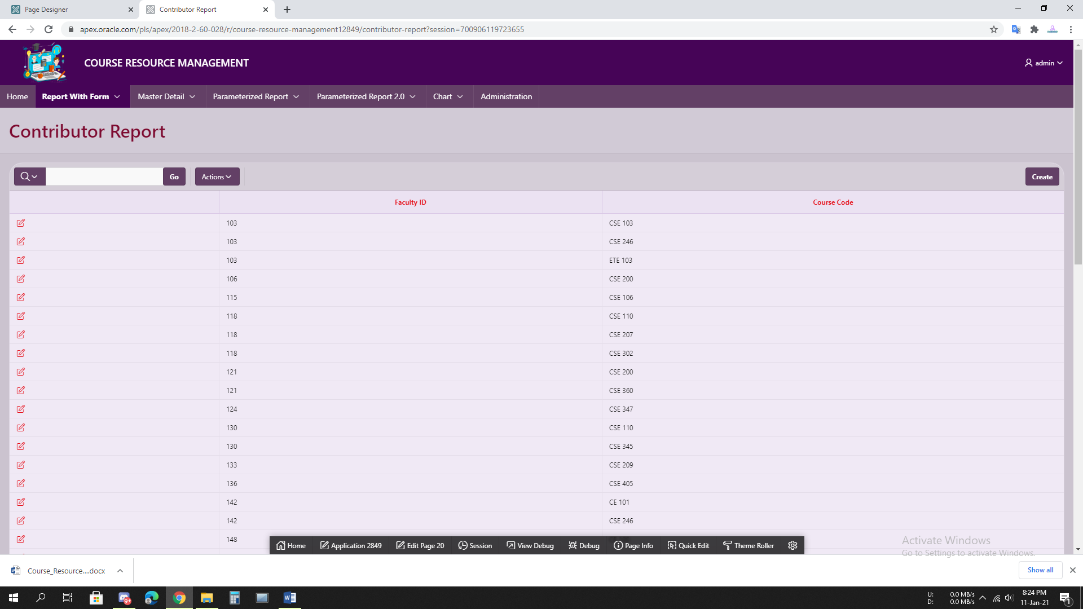

**4.7 Figure: Contributor Report**

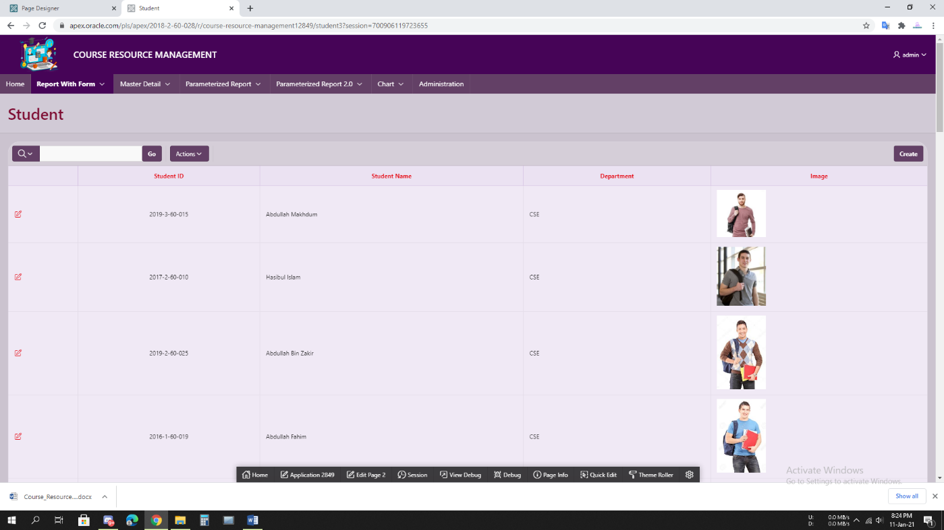

**4.8 Figure: Student**

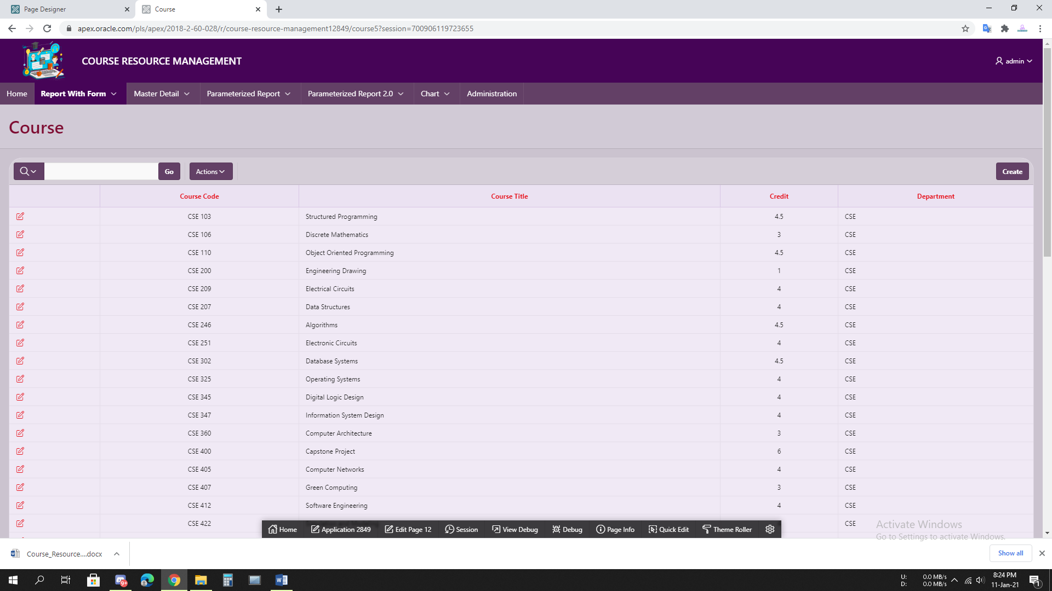

**4.9 Figure: Course**

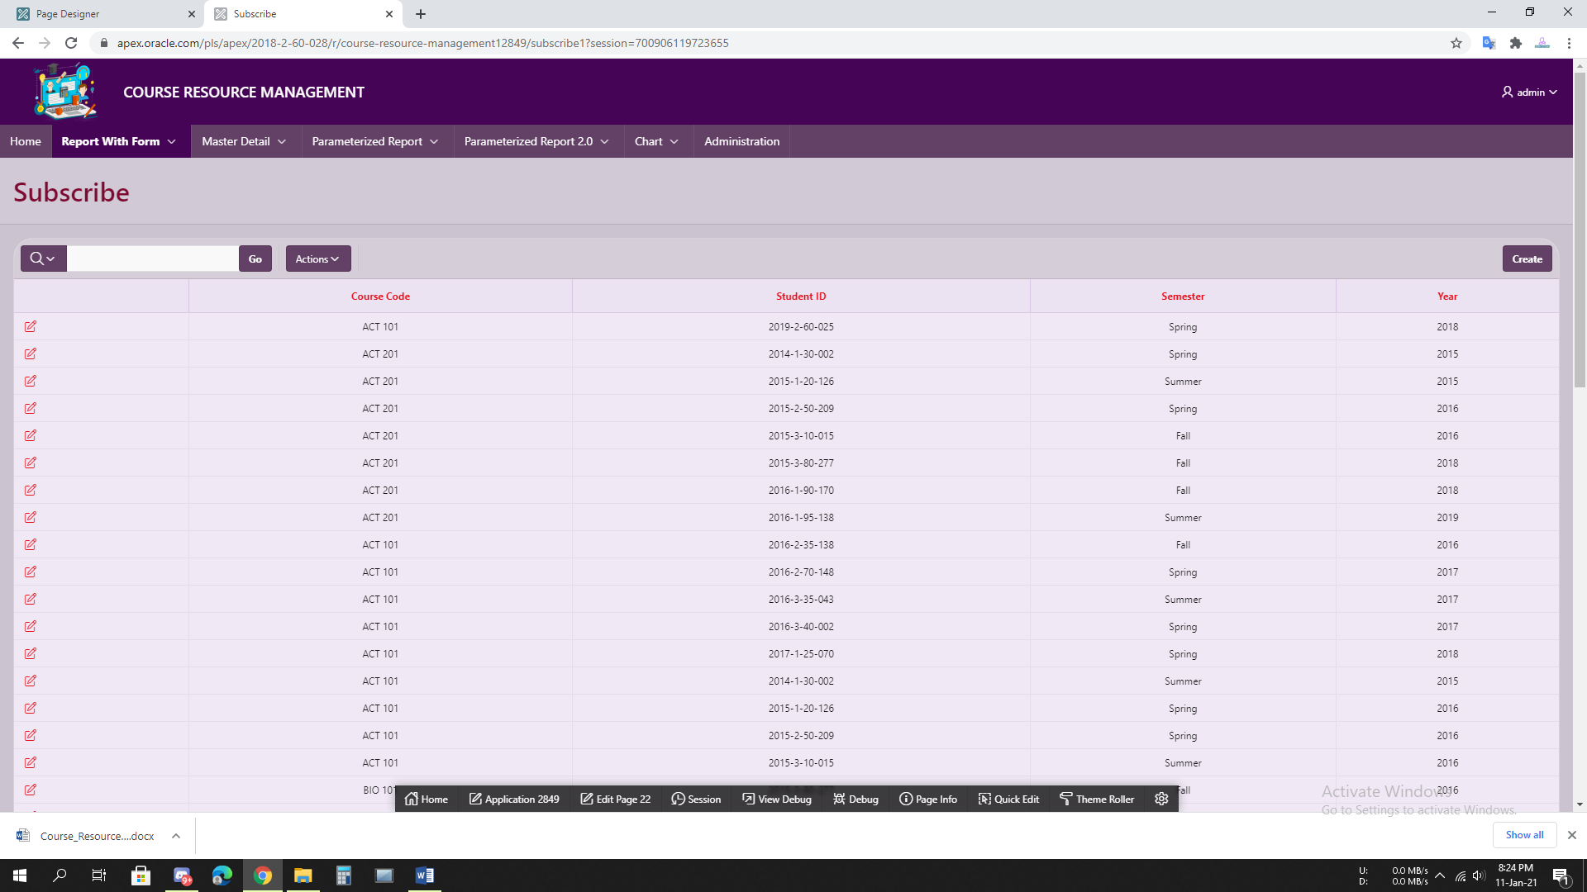

**4.10 Figure: Subscribe**

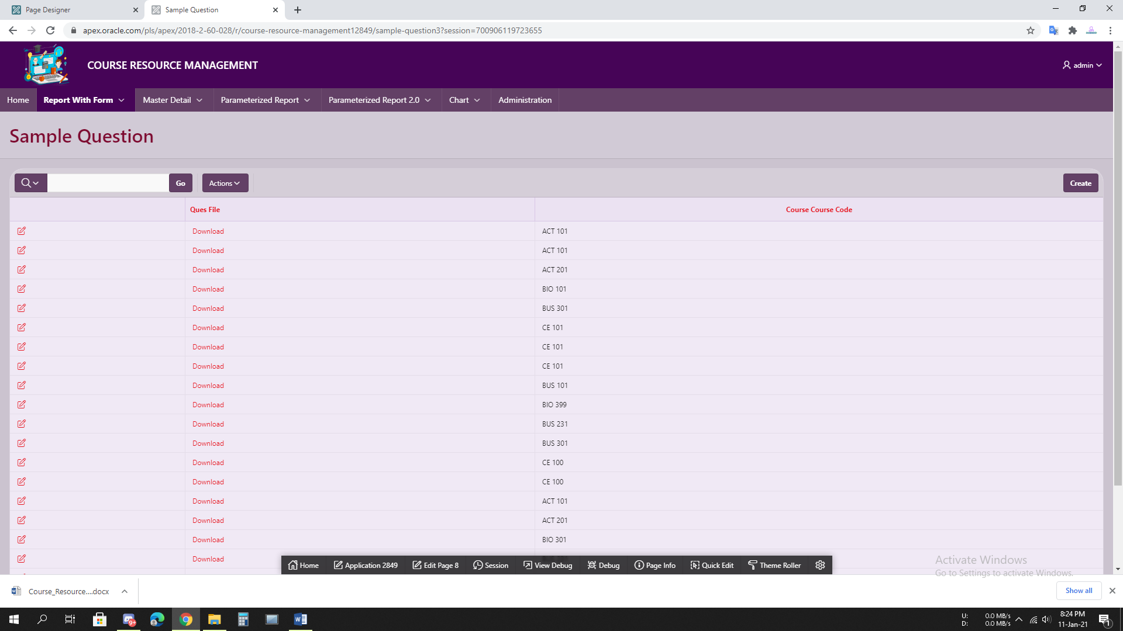

**4.11 Figure: Sample Question**

# 5 .Master-Detail Form

|  |  |  |  |  |  |  |  |  |  |  |  |  |  |  |  |  |  |  |  |  |  |  |  |  |  |  |  |
| --- | --- | --- | --- | --- | --- | --- | --- | --- | --- | --- | --- | --- | --- | --- | --- | --- | --- | --- | --- | --- | --- | --- | --- | --- | --- | --- | --- |
| |  |  |  | | --- | --- | --- | | Page Number and Name | Master Table (Parent) | Detail Table (Child) | | 48. **Course-Topic** | Course | Topic | | 51. **Department-Course** | Department | Course | | 75. **Faculty-File** | Faculty | All_File | | 42. **Faculty-Course** | Faculty | Course | | 33. **Sample-Question** | Course | Sample_Question | | 57. **Department-Student** | Department | Student | | 54. **Student-Course** | Student | Course | | 69. **File-Rating** | File | Rating | |

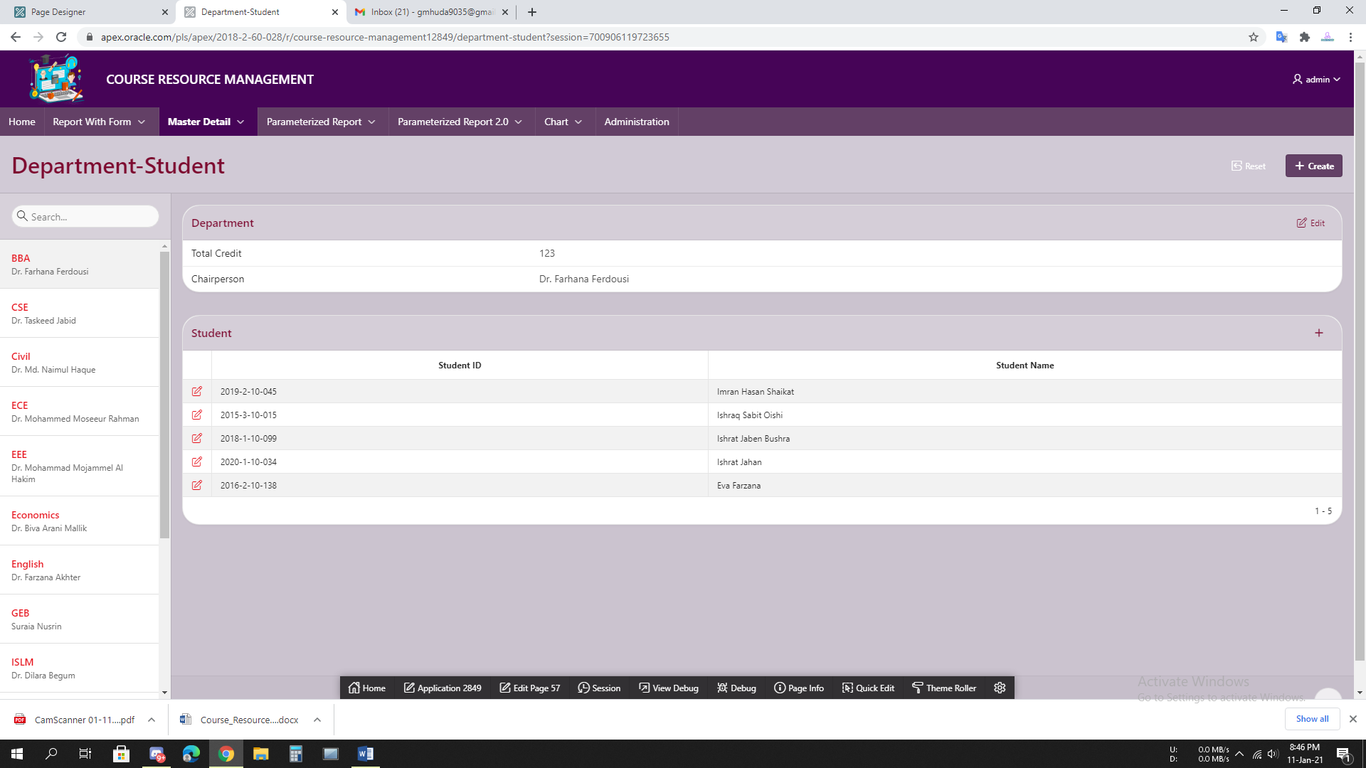

**5.1 Figure: Department-Student**

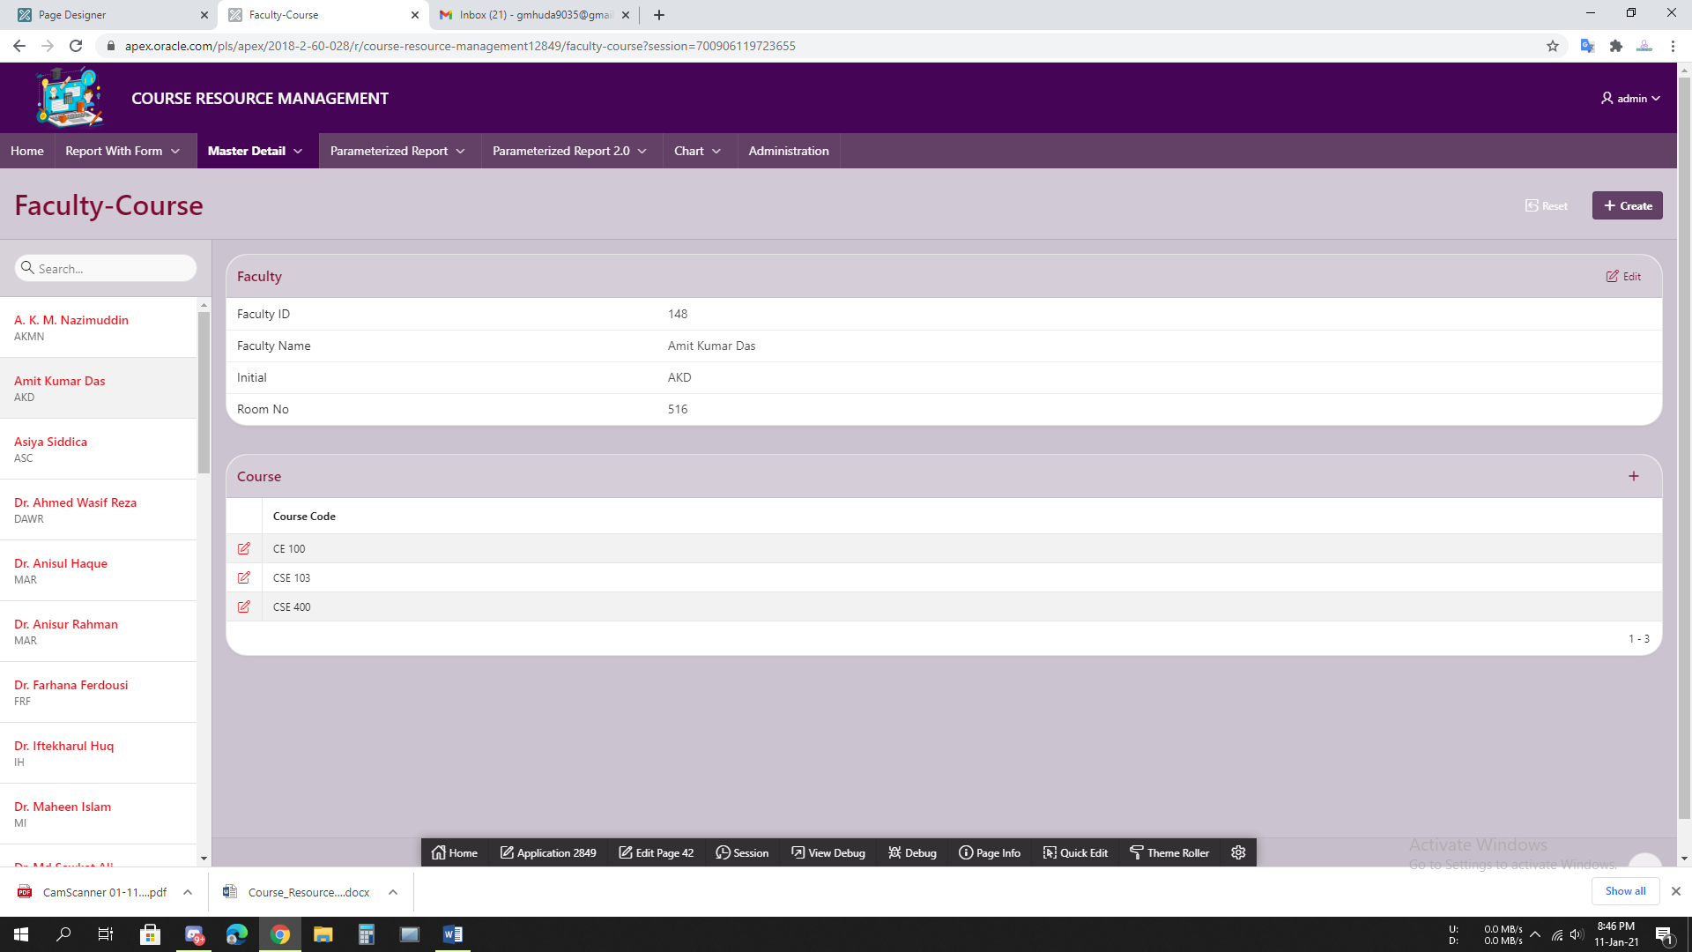

**5.2 Figure: Faculty-Course**

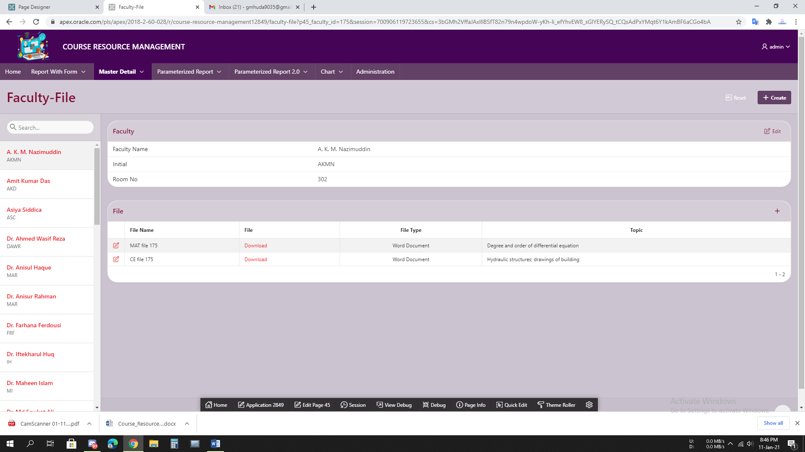

**5.3 Figure: Faculty-File**

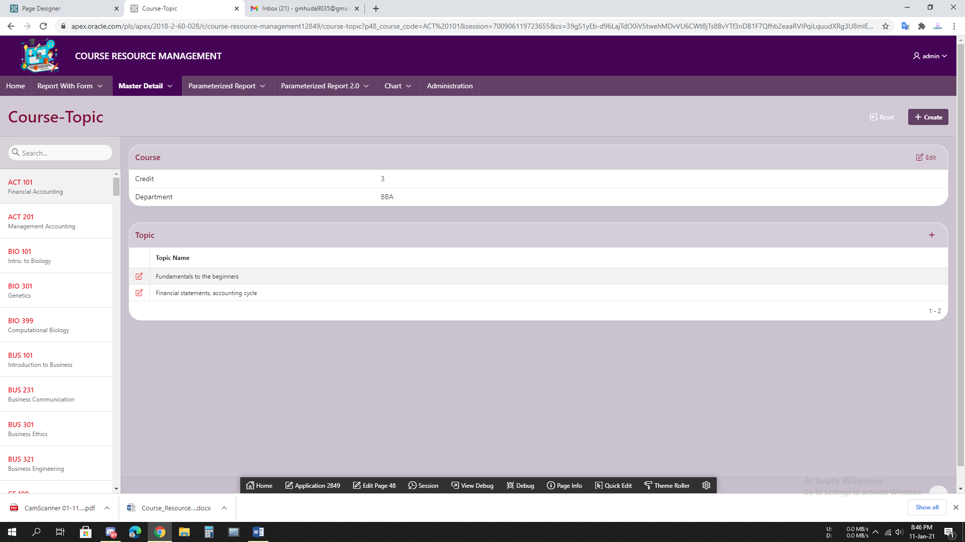

**5.4 Figure: Course-Topic**

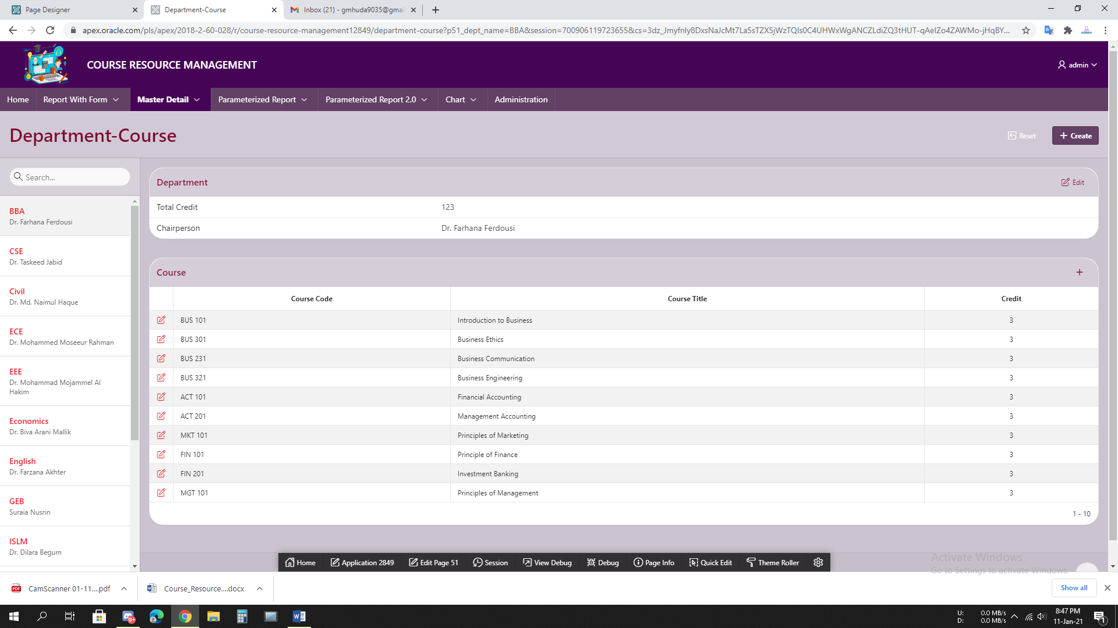

**5.5 Figure: Department-Course**

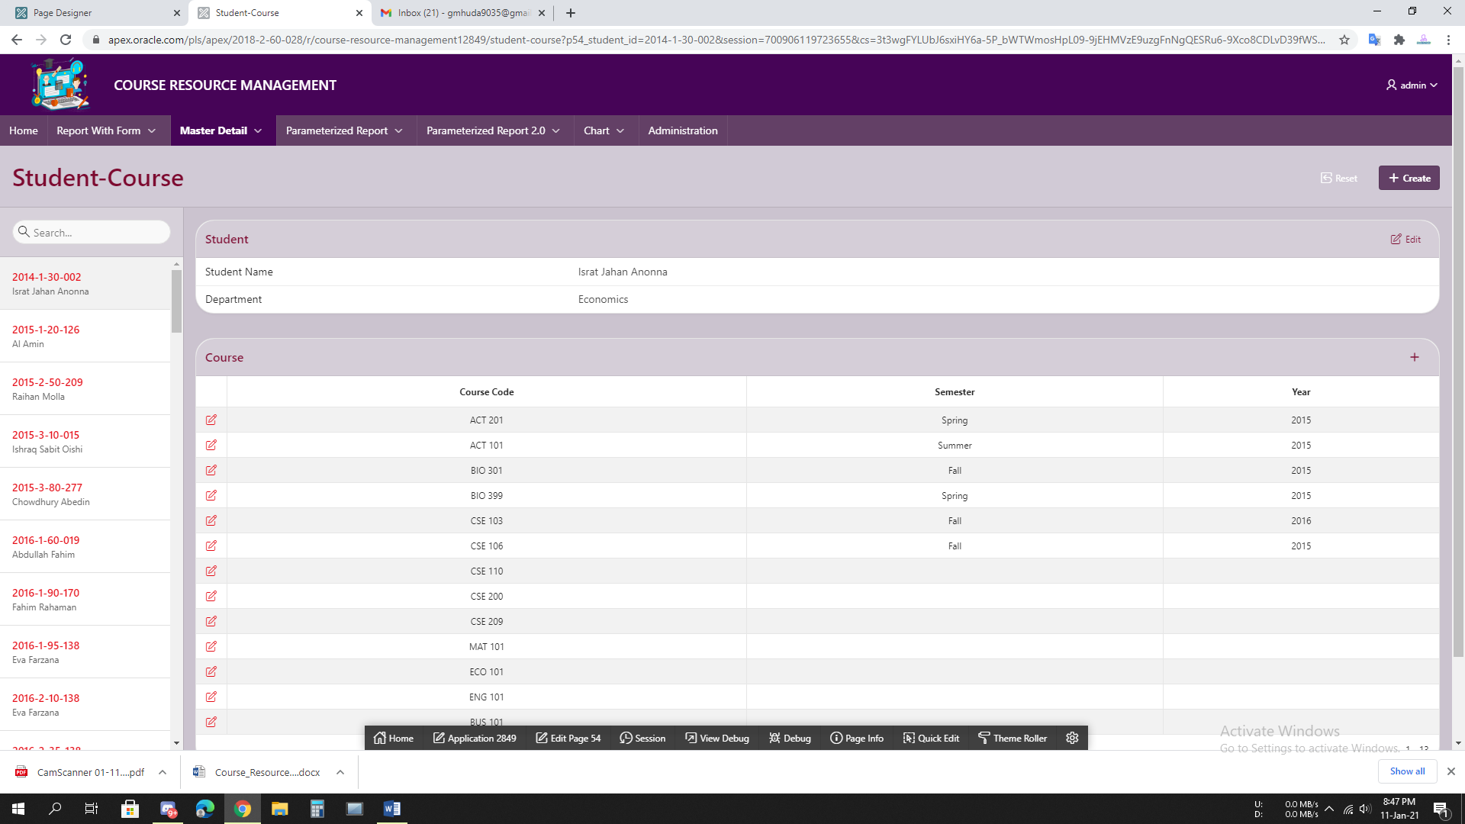

**5.6 Figure: Student-Course**

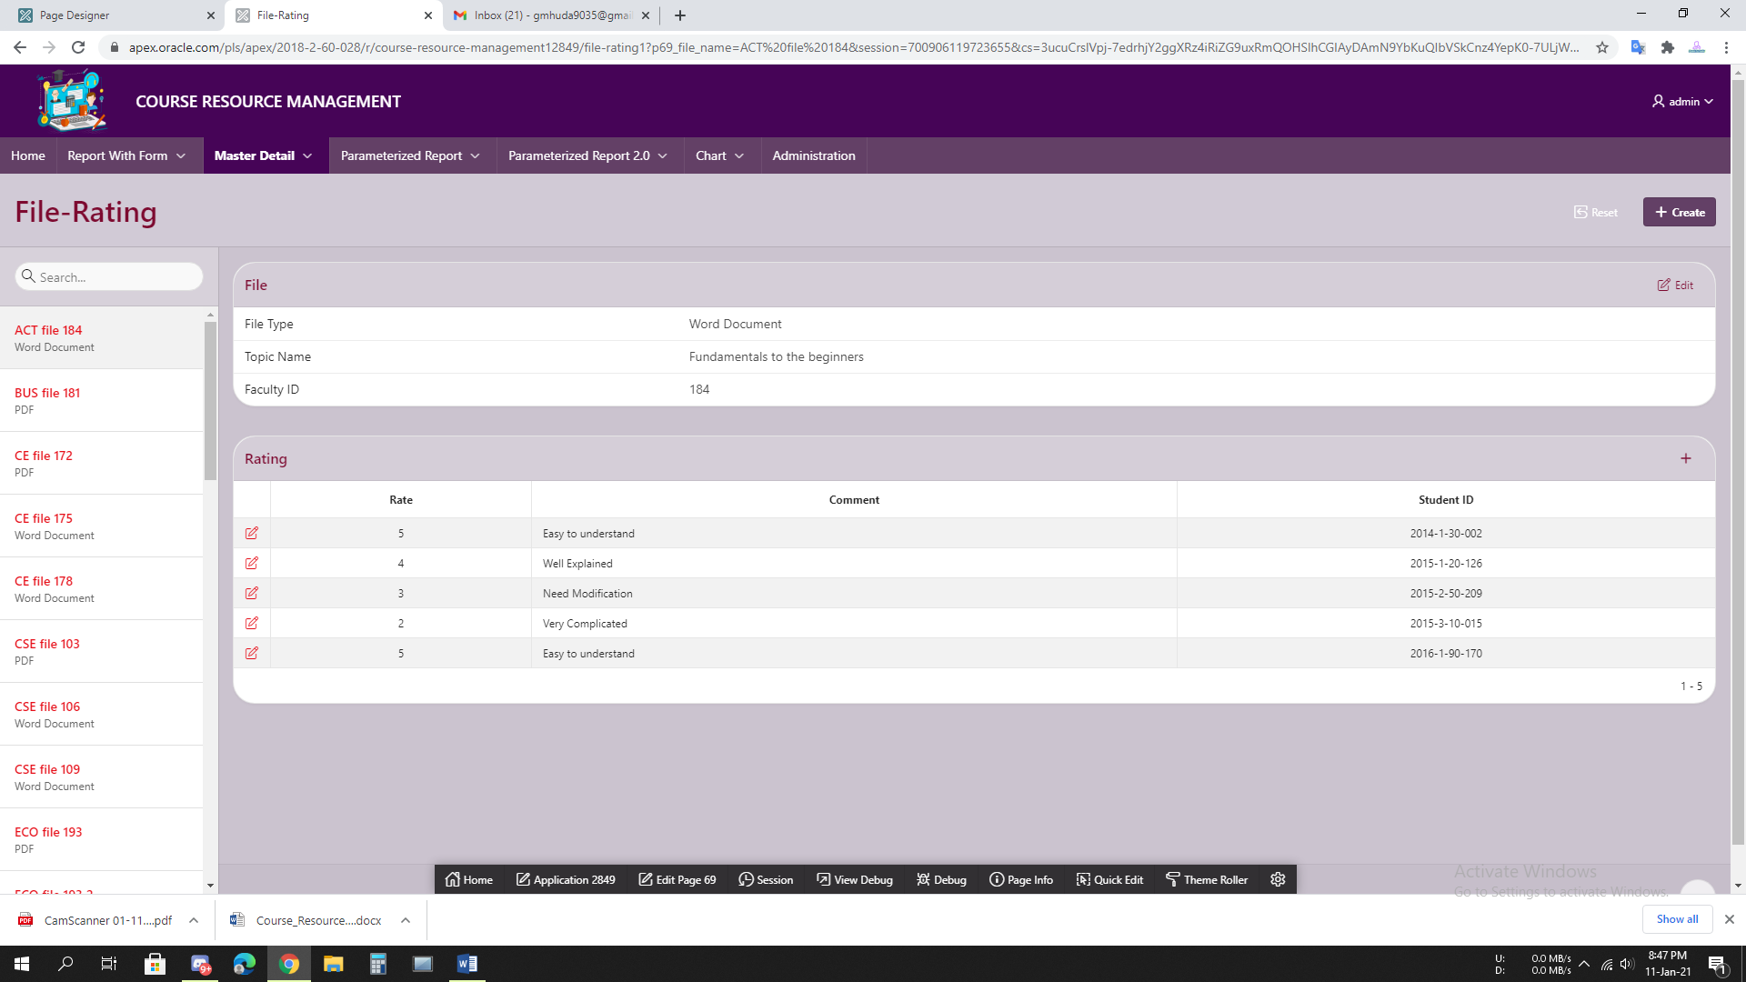

**5.7 Figure: File-Rating**

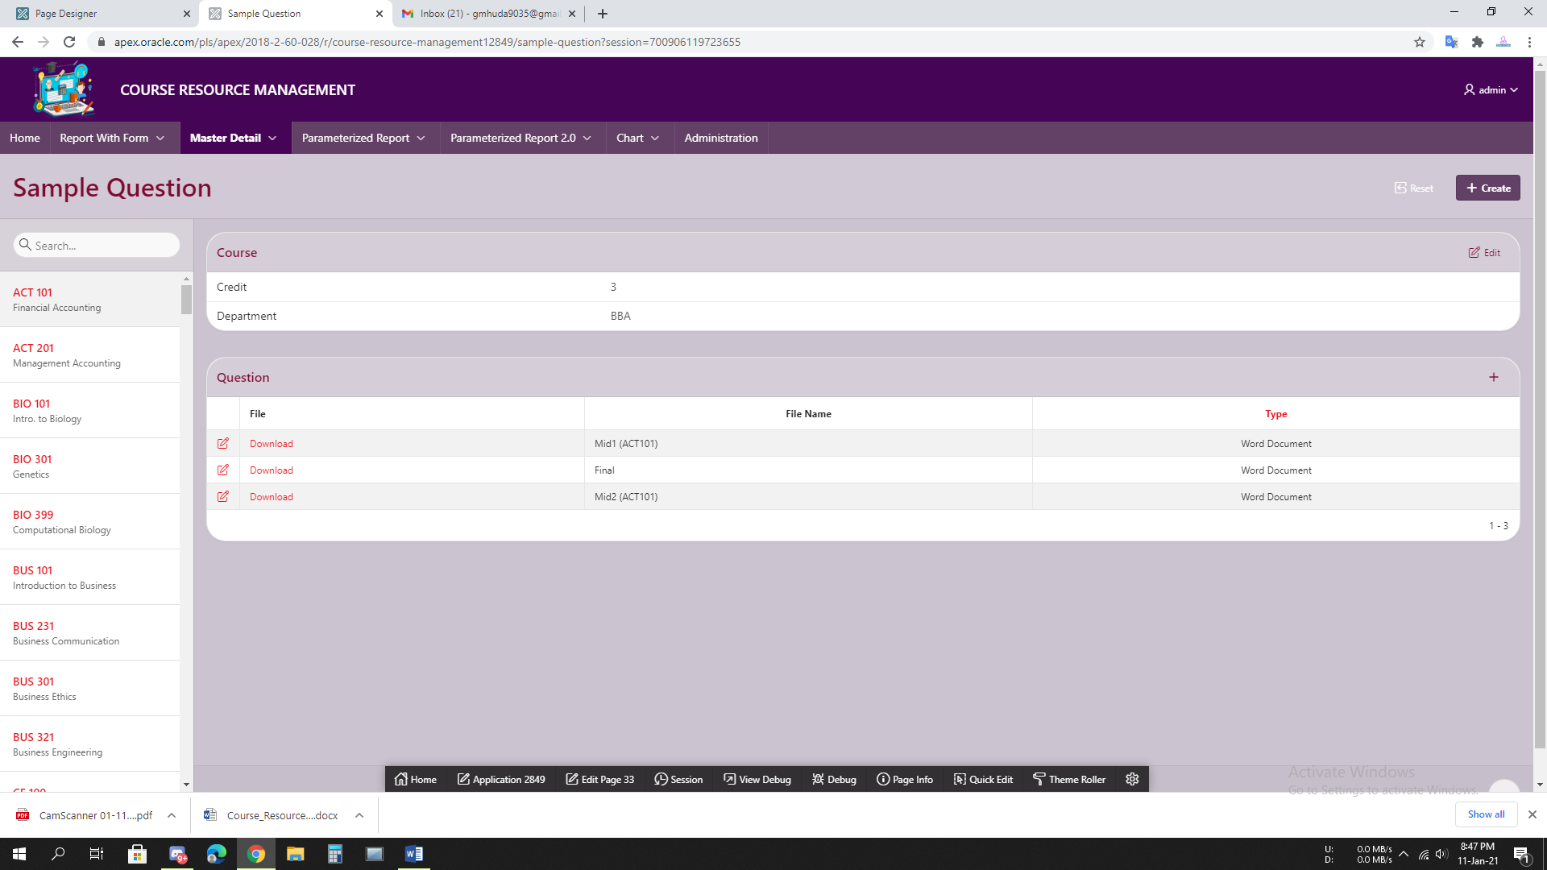

**5.8 Figure: Sample Question**

# 6. Reports based on Multi-Table and Aggregate Queries

|  |  |  |
| --- | --- | --- |
| Page Number and Name | Query Type | Report description |
|  |  |  |
|  |  |  |
|  |  |  |
|  |  |  |
|  |  |  |

# 7. Parameterized Reports

|  |  |  |
| --- | --- | --- |
| Page Number and Name | Given Input | Report description |
| **60. Course-Faculty** | Course code | Faculty members assigned to the Courses |
| **42. Course-File** | Course code | Files assigned to the Courses |
| **66. Topic-File** | Topic | Files assigned to the Topics |
| **79. Course-Book** | Course code | Books assigned to the Courses |
| **80. Topic-Book** | Topic | Books assigned to the Topics |
| **57. Course-Student** | Course code | Students assigned to the Courses |
| **84. Department-Book** | Select Department | Department Wise Books |
| **82. Student.Dept-Course.** | Select Student’s ID And Department. | Which Course HE or SHE will take. |
| **83. Course.Dept-Student.** | Select Course and department. | Which Students Take that Course |
| **85. Dept.Course-Book** | Select Department And Course. | That particular department and course related books show. |
| **94. Course.Topic-File** | Select Course and Topic. | That particular course and topic related files show. |
| **96. Course.Topic-Book** | Select Course and Topic. | That particular course and topic related books show. |

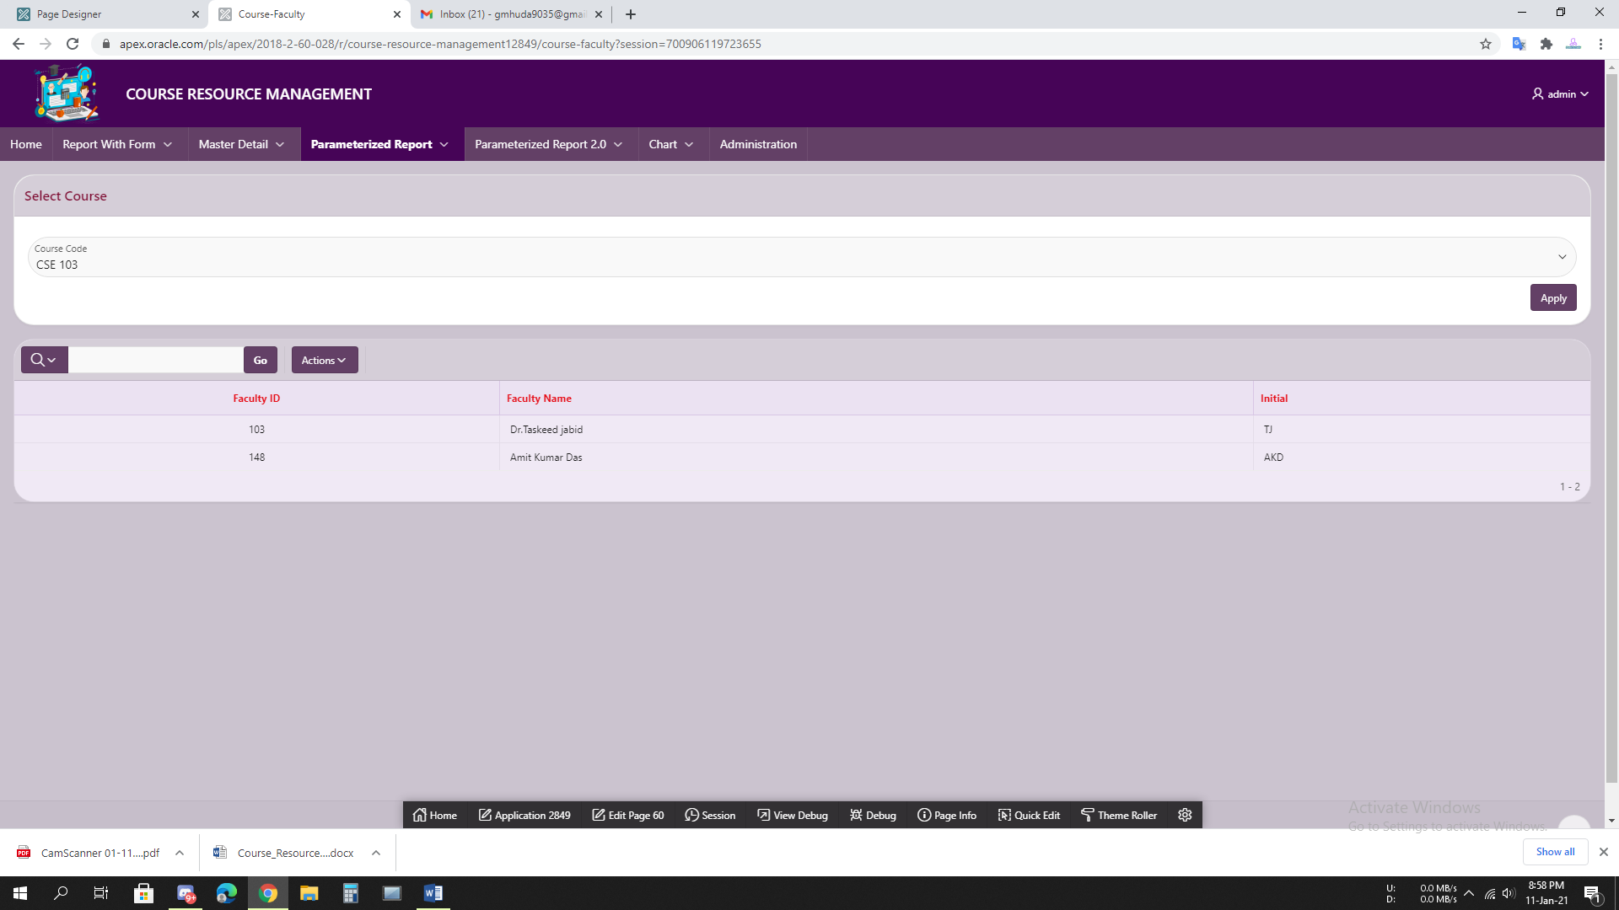

**7.1 Figure: Course-Faculty**

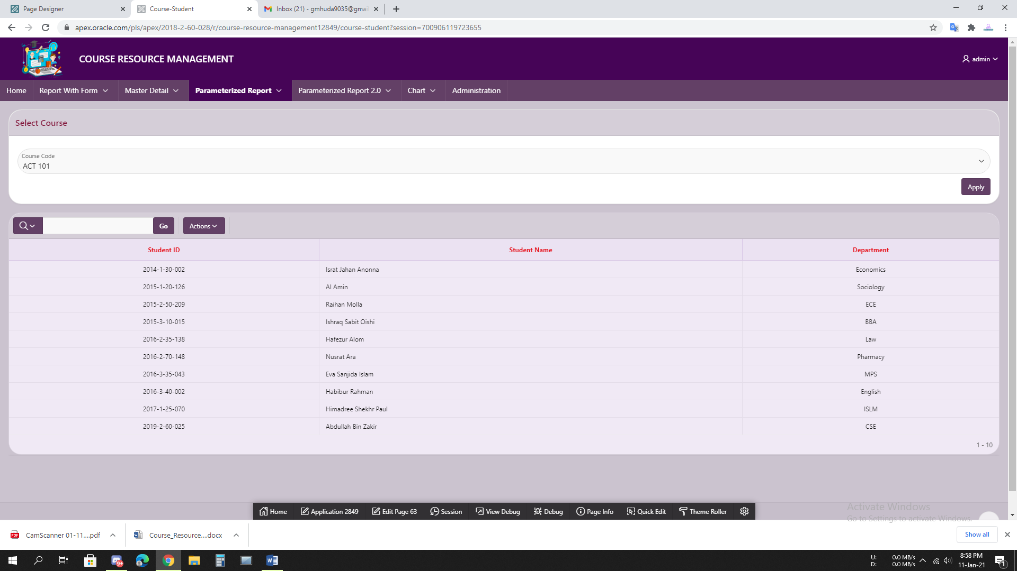

**7.3 Figure: Course-Student**

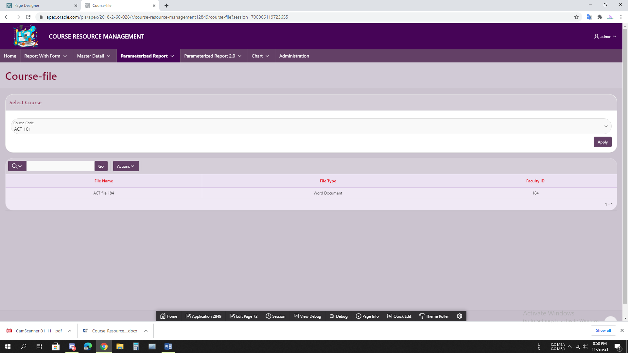

**7.4 Figure: Course-File**

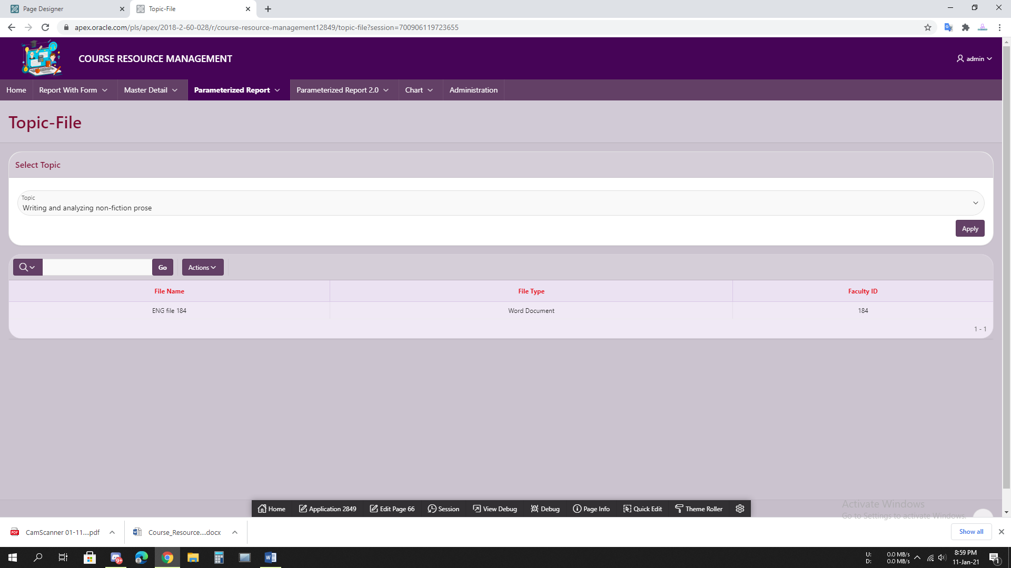

**7.5 Figure: Topic-File**

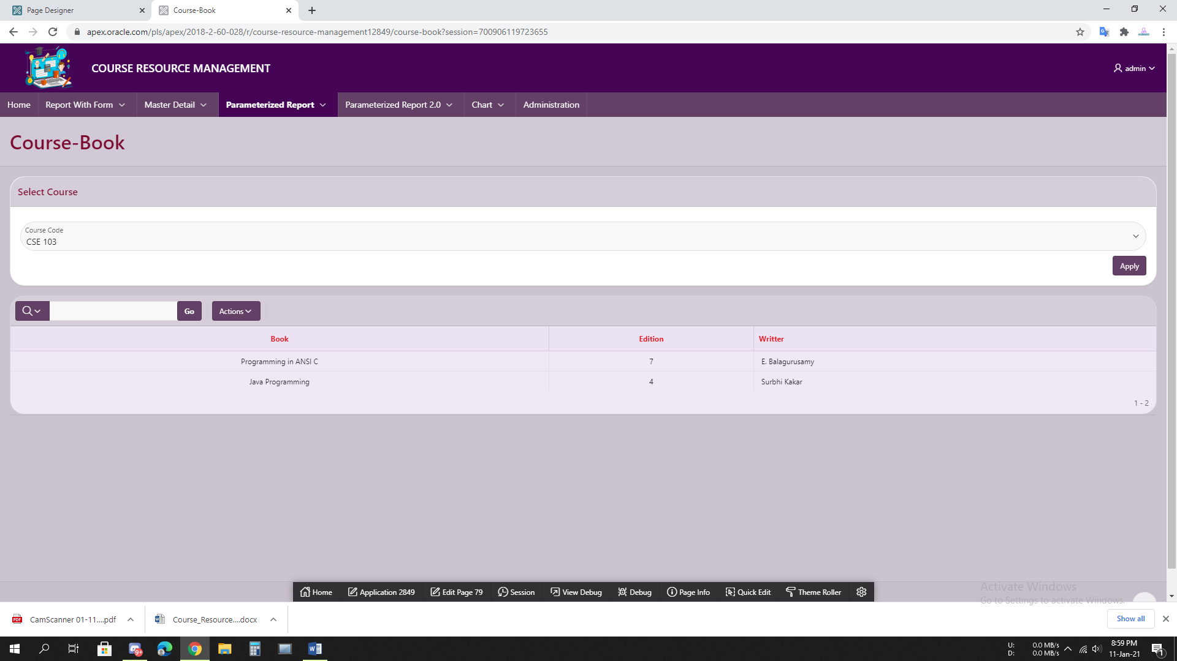

**7.6 Figure: Course-Book**

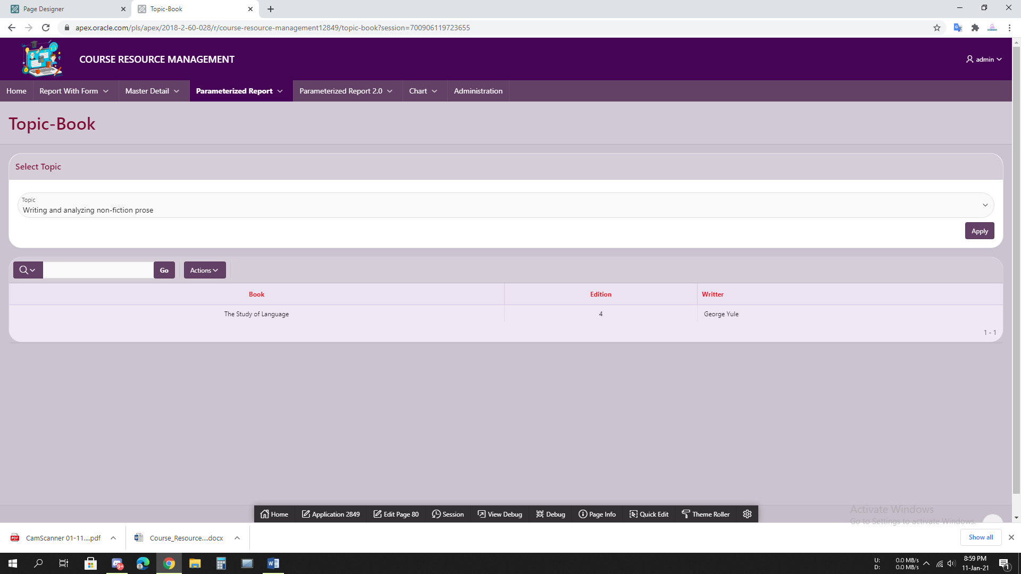

**7.7 Figure: Topic-Book**

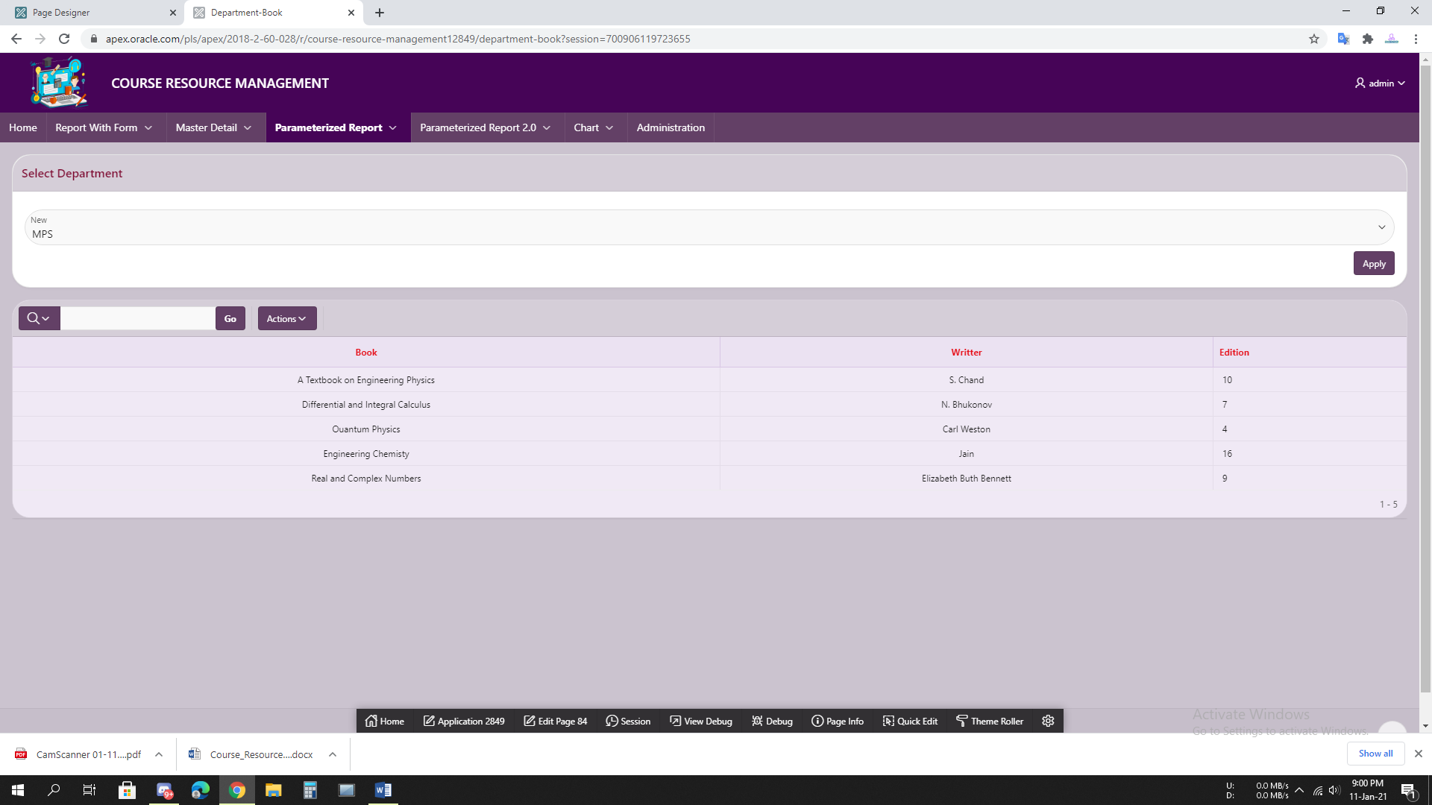

**7.8 Figure: Department-Book**

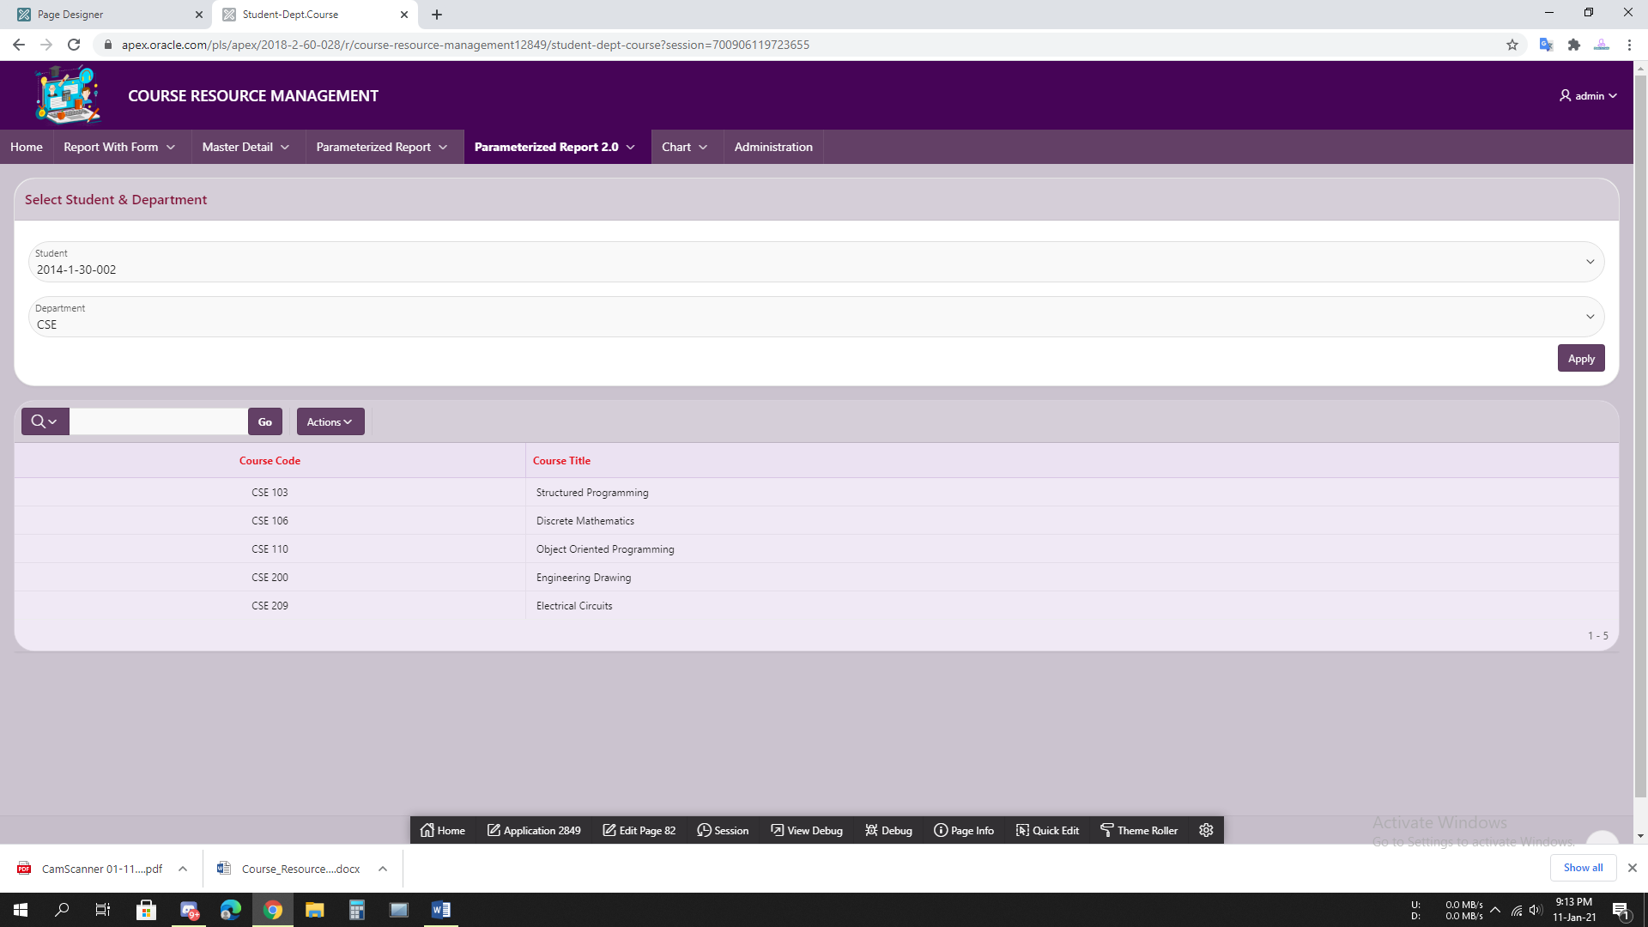

**7.9 Figure: Student.Dept-Course**

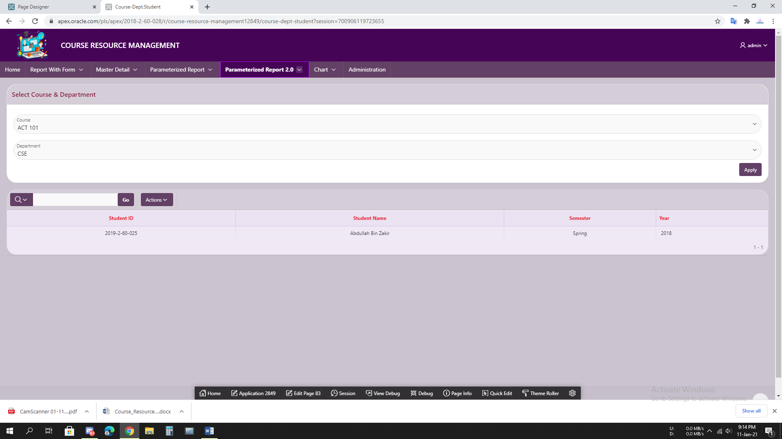

**7.10 Figure: Course.Dept- Student**

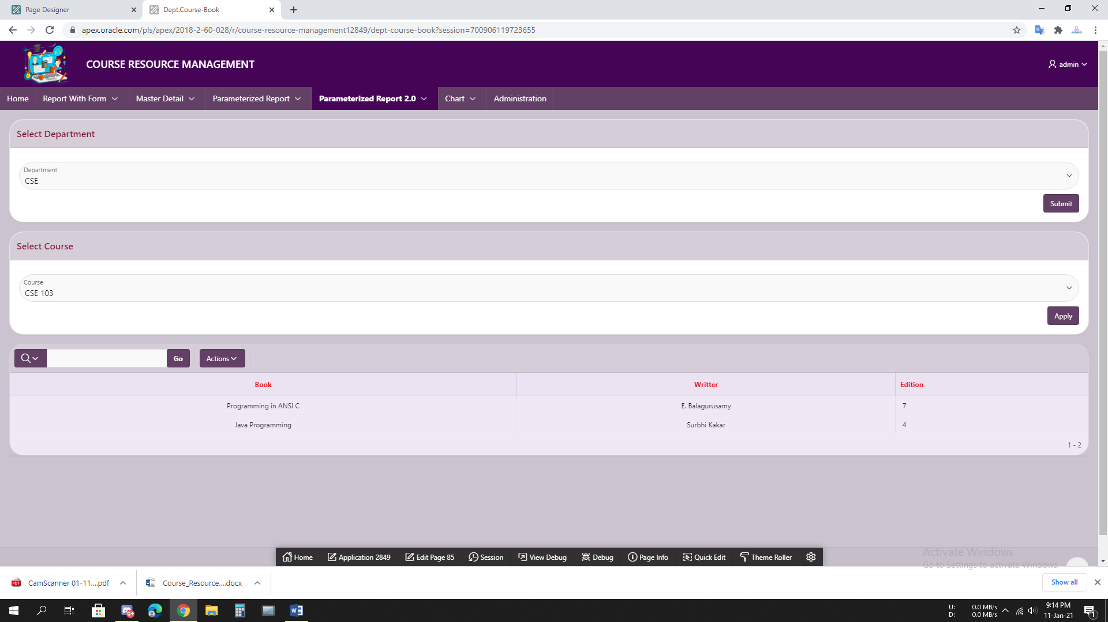

**7.11 Figure: Dept.Course-Book**

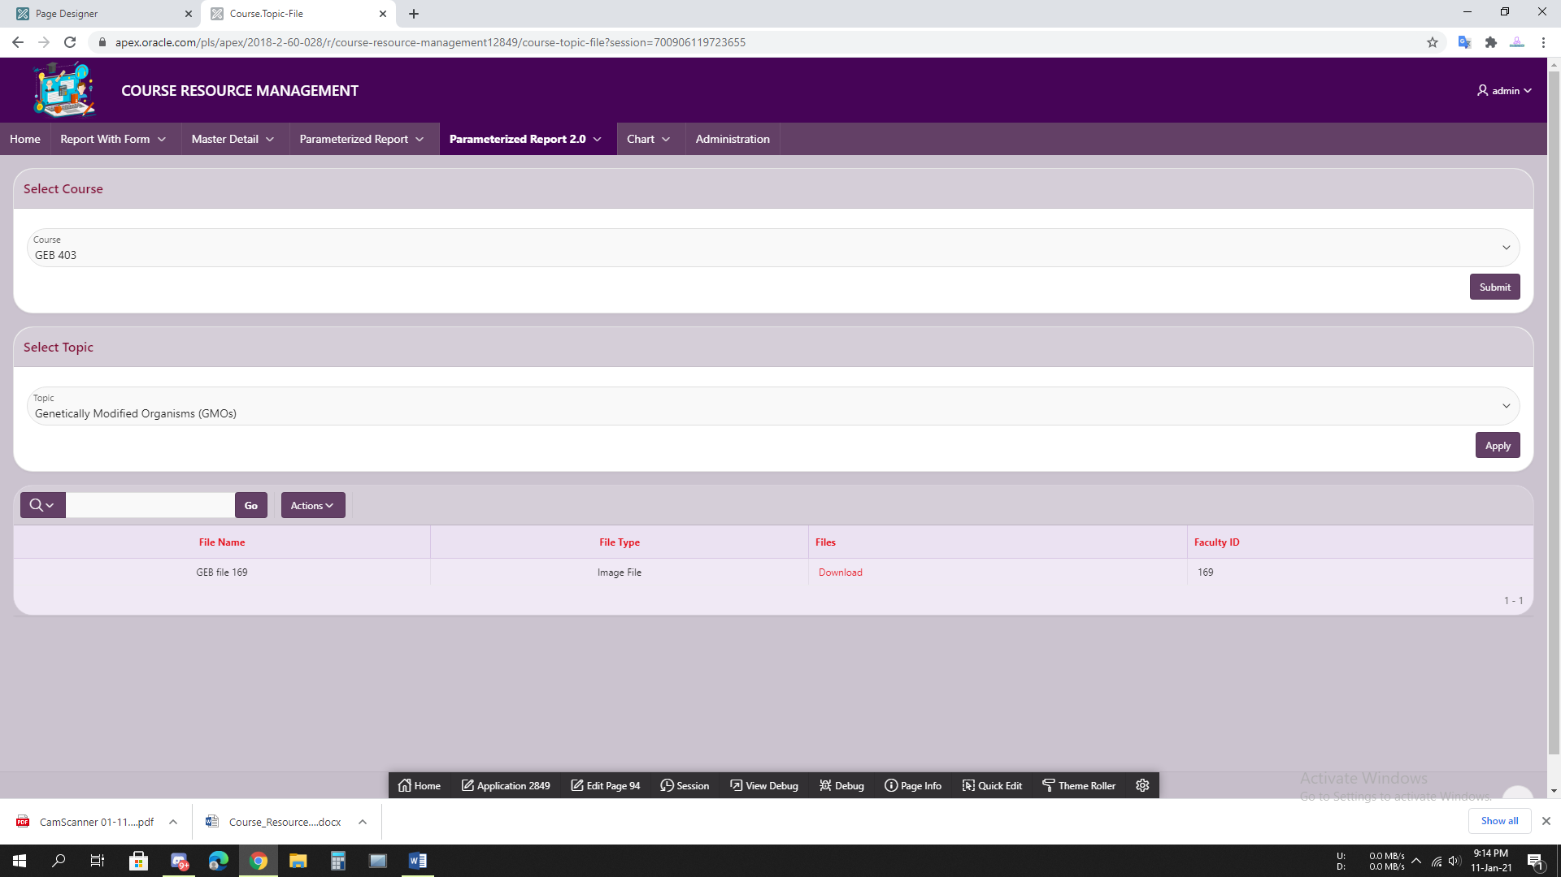

**7.12 Figure: Course.Topic-File**

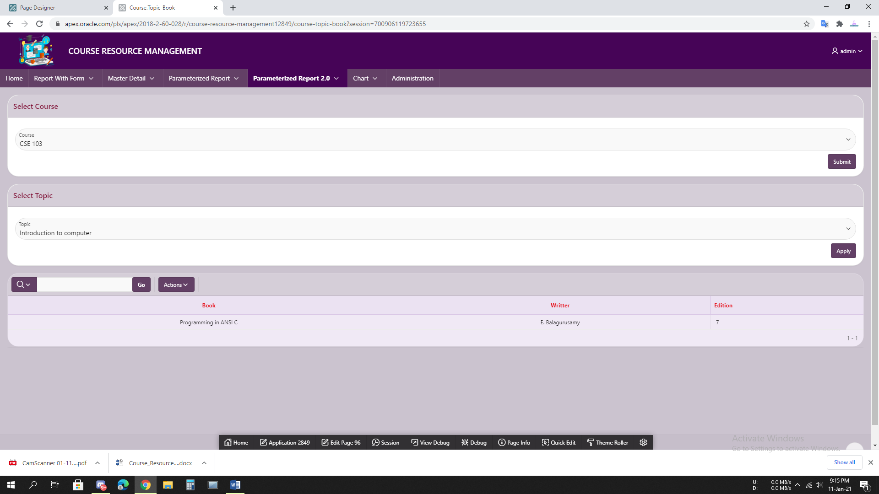

**7.13 Figure: Course.Topic-Book**

# 8.Charts

|  |  |
| --- | --- |
| Page Number and Name | Chart description |
| write your page number and name here | Write the description of the chart in a simple sentence such as this bar chart shows the number of students enrolled per semester at each year. |
| **87. File-Comment** | First select File and then Show Number of each comments |
| **88.File-Rating** | First Select File then Show Number of Each Rate. |
| **89.Faculty-File** | Select Faculty then Show Number of File uploaded in each course. |
| **90.Department-Course** | Number of Course In each Department |
| **93.Department-student** | Number of Students In each Department |

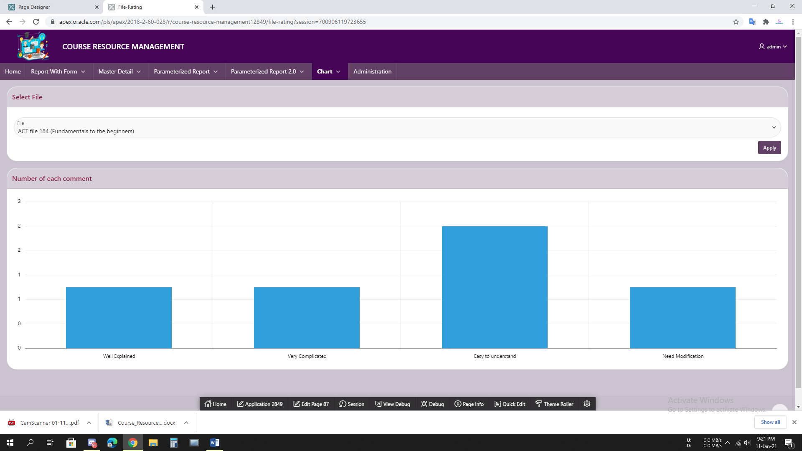

**8.1 Figure: File-Comment**

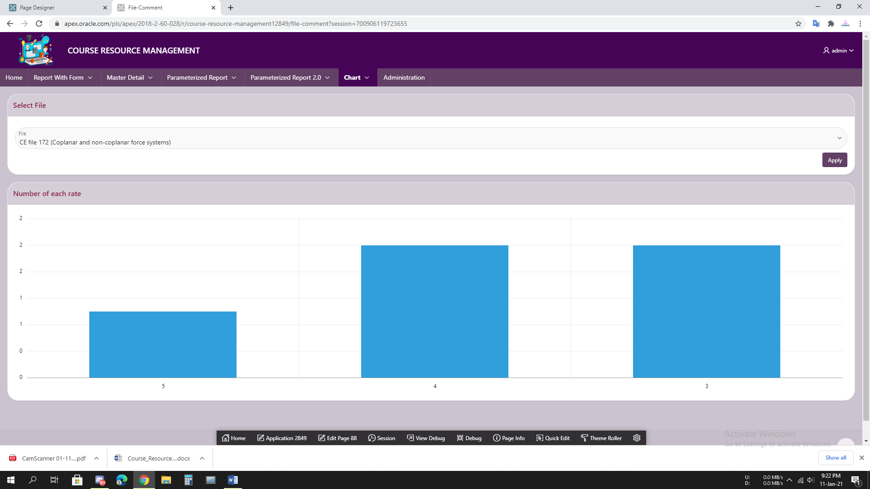

**8.2 Figure: File-Rating**

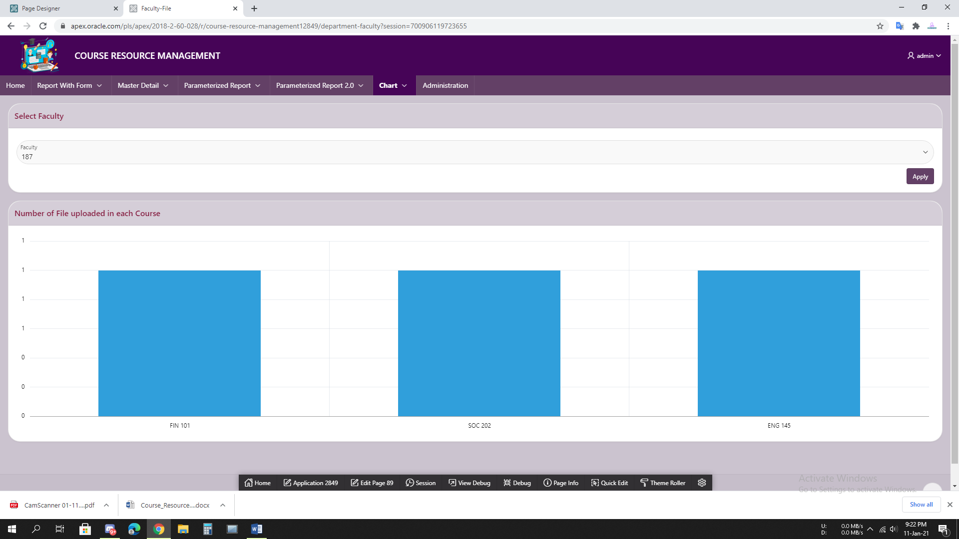

**8.3 Figure: Faculty-File**

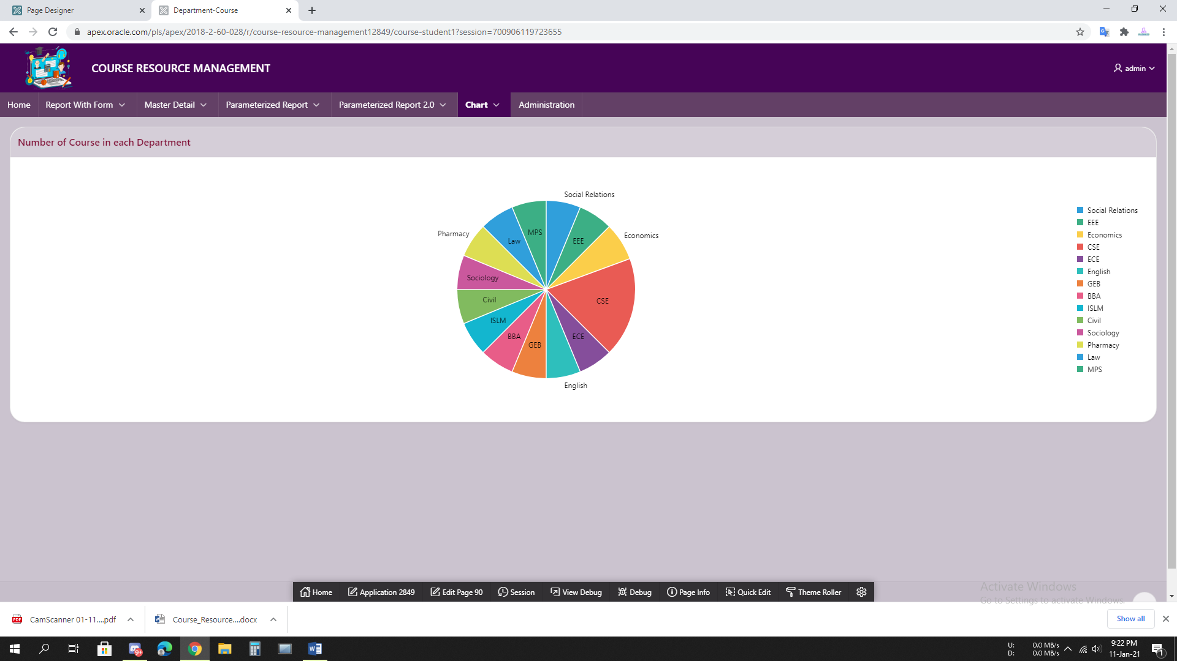

**8.4 Figure: Department-Course**

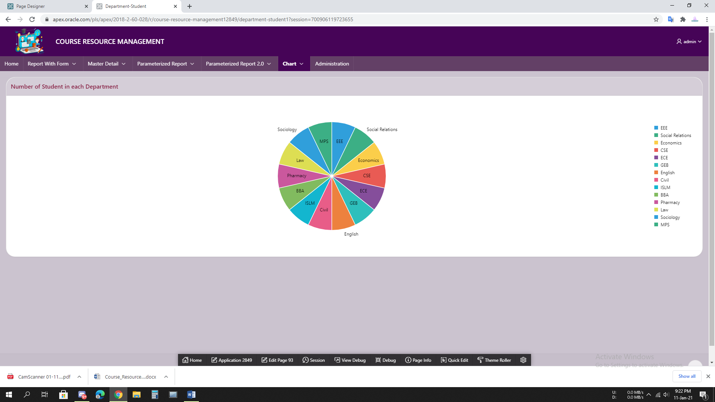

**8.5 Figure: Department-Student**

# 9.Authorization and User Role Assignment

**User Role Assignment**

|  |  |  |
| --- | --- | --- |
| User name | Password | Role |
| admin | admin | Administrator |
| faculty | faculty | Contributor |
| student | student | Reader |
|  |  |  |

**Page-wise Authorization Information**

|  |  |
| --- | --- |
| Page number and name | Authorization Level |
| 4. Student | Contribution Rights |
| 8. Course-Faculty | Contribution Rights |
| 10. Student-Course | Contribution Rights |
| 14. Course-Student | Contribution Rights |
| 16. Faculty-Course | Contribution Rights |
| 18. Rating | Reader Rights |
| 20. Contributor | Contribution Rights |
| 22. Subscribe | Reader Rights |
| 82. File-Comment | Contribution Rights |
| 83. File-Rating | Contribution Rights |
| 85. Faculty-File | Contribution Rights |
| 94. Student.Dept-Course | Contribution Rights |
| 96. Course.Dept-Student | Contribution Rights |

**About Button Authorization:**

* Student as an user (Reader) can not add or alter any data without Rating and Subscribe Form. Because the buttons of other forms and reports have been set as either Contribution Rights or Administration Rights.
* Faculty as an user (Contributor) can not add or alter any data without All Files Form. Because the buttons of other forms and reports have been set as Administration Rights.

# 10. Concluding Remarks

Experience in Oracle Apex was sometime tough, sometime better and so on. As Oracle Apex is very user friendly, building the website was always interesting. Though we know only a little, it was very much favourable to build the first database-based application. Also it was our first application and had to face some difficulties to cover the **File** system and **Authentication**. But we tried out best to finish the required task. Some experience-

* It was really confusing to choose that should we make the navigation menu user-friendly or presentation-friendly. We chosed the second one.
* Managing the File system in parameterized report was a little bit confusing.
* At the middle of the application building, we always wanted to extend our ER Model.